Implement Content Manager on WAS Network Deployment on Linux Server

This topology includes the following elements:



A load balancer directs incoming requests to the caching proxy and a second load balancer to manage the workload across the HTTP servers.

Load Balancer is included in WebSphere Application Server Edge Component. Load Balancer distributes incoming client requests across servers, balancing workload and providing high availability by routing around unavailable servers. A backup server is configured for each primary Load Balancer to provide high availability.

A Caching Proxy with a backup server in passive mode for high availability. Caching Proxy is included in WebSphere Application Server Edge Components. Cacheable content includes static web pages and JavaServer Pages (JSPs) with dynamically generated but infrequently changed fragments. The Caching Proxy can satisfy subsequent requests for the same content by delivering it directly from the local cache, which is much quicker than retrieving it again from the content host.

Two IBM HTTP Server Web servers configured in a cluster Incoming requests for static content are served by the web server. Requests for dynamic content are forwarded to the appropriate application server by the web server plug-in.

A dedicated server hosts the deployment manager. The deployment manager is required for administration but is not critical to the runtime execution of applications. Having a separate server for the deployment manager instead of placing it in on one of the node’s servers leaves more resources available for the application servers. Also if a problem occurs with the node server, the administration of the other nodes is still possible. Additionally, the deployment manager has a master copy of the configuration that must be backed up on a regular basis.

Two clusters consist of three application servers. Each cluster spans two machines. In this topology, one cluster contains application servers that provide the web container functionality of the applications (servlets and JSPs), and the second cluster contains the EJB container functionality. Whether you choose to use clusters is a matter of careful consideration. Although using clusters provides failover and workload management capabilities for web and EJB containers, it can also affect performance.

A dedicated database server runs the database.

Install the Library and the Resource manager, DB2 Enterprise Database, IBM HTTP Server (with WAS plugins), IBM Websphere Application Server on a single Linux workstation.

Set up central administration of client property files for ease of system management.

Install Tivoli® Storage Manager Client to provide access to long-term storage. Set up hierarchical storage architecture with local storage system and TSM storage system.

Set up pClient environment. The Client for Windows enables the agents to query, view, and update data stored on the DB2 Content Manager system from their own workstation desktops. Because it is a dedicated client, the Client for Windows has rich functionality and responds rapidly.

The Client for Windows requires cataloging the library server database on the client workstation. The DB2® Run-Time Client is required to catalog the database on the client workstation.

TIPS: How to delete a profile from a WebSphere application server.

1. Location of tool: <root>\AppServer\bin\manageprofiles.bat

manageprofiles.bat -delete -profileName <profile_name> (case sensitive commands)

Note: This used to be wasprofile.bat in version 6.0.x and is depricated in 6.1. The Windows service for the profile will have been set to disabled now.

1. Delete the folder e.g <root>\ApplicationServer\profiles\<profile_name>
2. manageprofiles.bat -validateAndUpdateRegistry

This process validates the profile registry and lists the non-valid profiles that it purges.

1. Remove the Windows service that is set to run the profile.

WASService.exe -remove service_name

TIPS: How to delete a service in Windows server.

1. You’ll want to open up the properties by double-clicking on the service name, and then highlight the “Service name” value and copy it to the clipboard. This is what we’ll need to disable it.

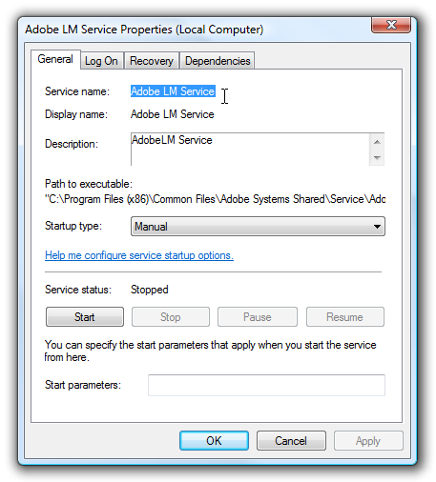

1. You’ll need to open up a command prompt, and if you are using Windows 7 or Vista you’ll need to right-click the command prompt and choose Run as Administrator. We’ll use the sc command to actually do the work.

sc delete ServiceName

1. If your service name has spaces in it, you’ll need to wrap the service name in quotes, like this:

sc delete “Adobe LM Service”

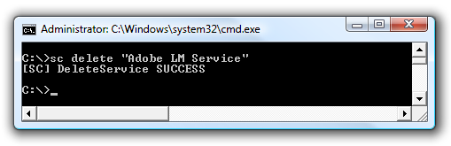

Note: You should think long and hard before deleting a service, because it’s very difficult to get them back once they are gone.

**IBM® WebSphere® Application Server Network Deployment Trial Version 8.5.5**

**Download this WAS ND Version 8.5.5, and install it on Windows Server,** Start IBM Installation Manager

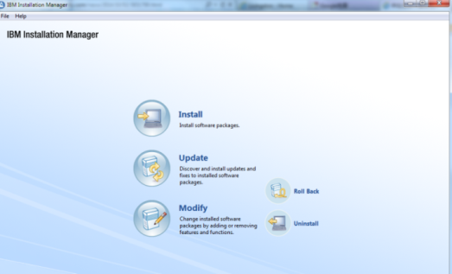

Choosing Repository

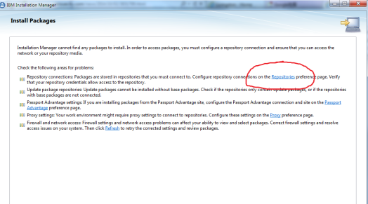

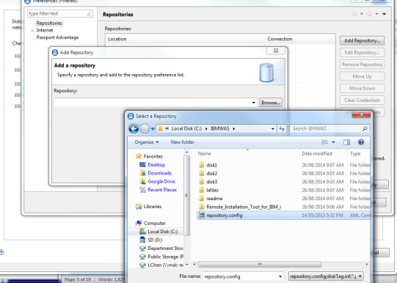

Select IBM WebSphere Application Server Network Deployment Trail - Version 8.5.5.0

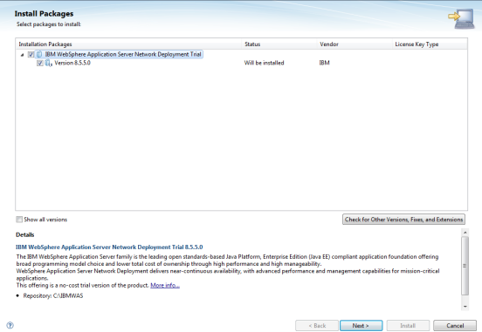

Accept the terms in the license agreement

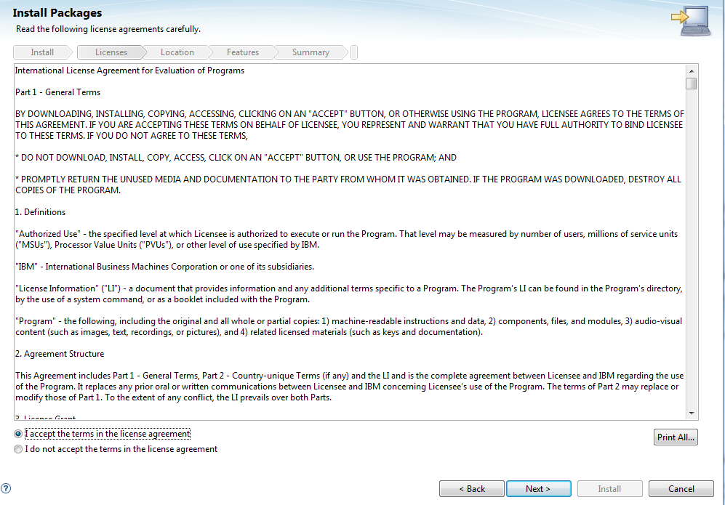

Select WAS Code Installation Location

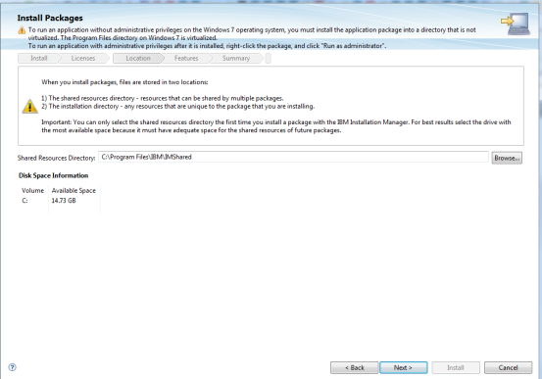

Select support languages

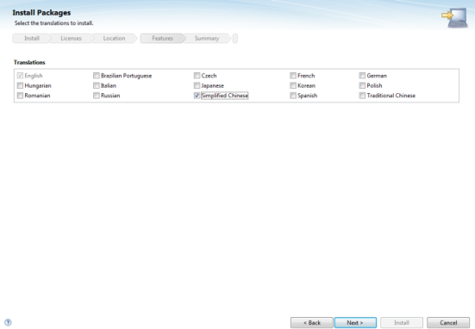

Select Productions

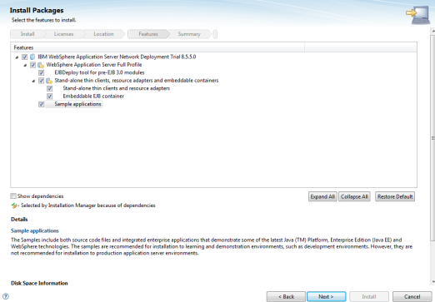

Start Code Installation

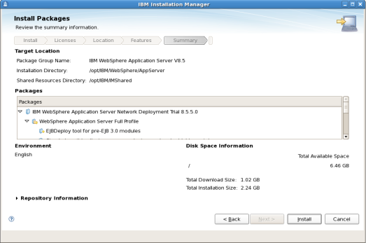

After WAS Production Code installation, First Step, creating a profile for Deployment manager.

By creating WebSphere Application Server’s cell Environment, which will include a management profile and an application server profile. A deployment manager is created (installed) and the new application server is also created and federated to the cell of the deployment manager.

You can also choose Management, which will create 3 different management profiles: 1. Administrative agent, 2. Deployment management and 3. Job manager.

Deployment manager provides management capability for multiple federated nodes, it can manage node that span multiple systems and platforms. The nodes that are managed by a deployment manager can only be managed by a single deployment manager and must be federated to the cell of that deployment manager.

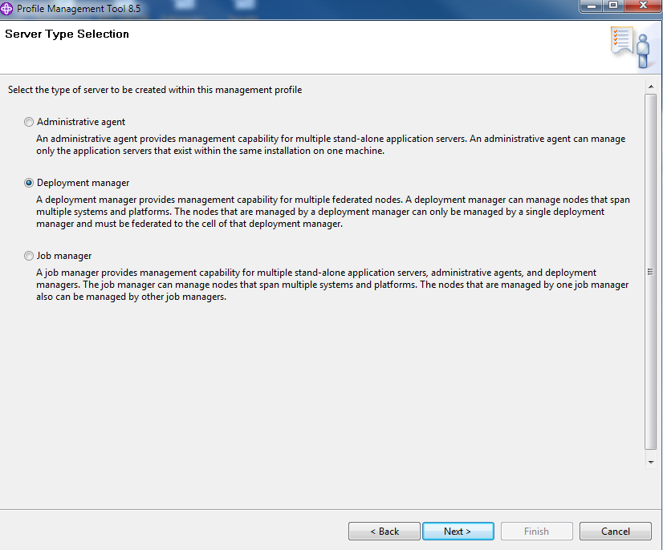

Typical profile creation, which means using default configuration names(profile, node, host and cell) and default configuration ports(Administrative console port, Administrative console security port, Deployment manager bootstrap port and Deployment manager SOAP connector port)

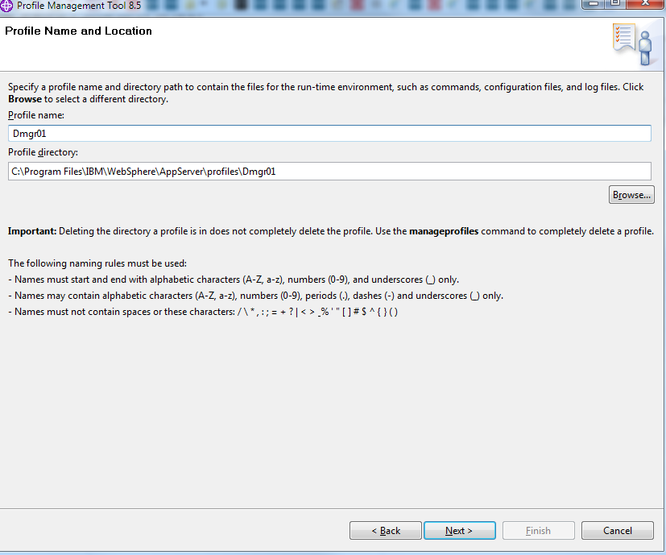

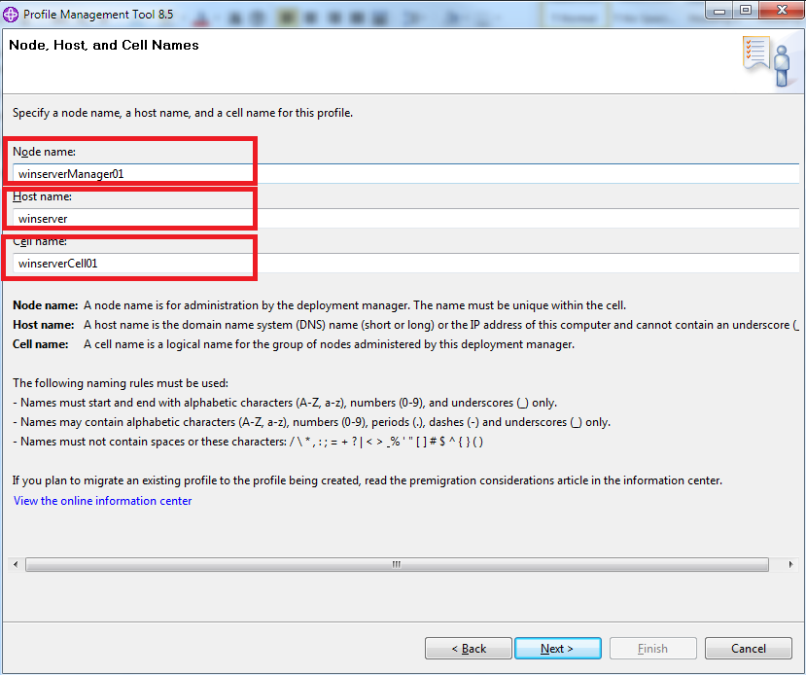

Node Name: winserveManager01

Host Name: winserver

Cell Name: winserverCell01

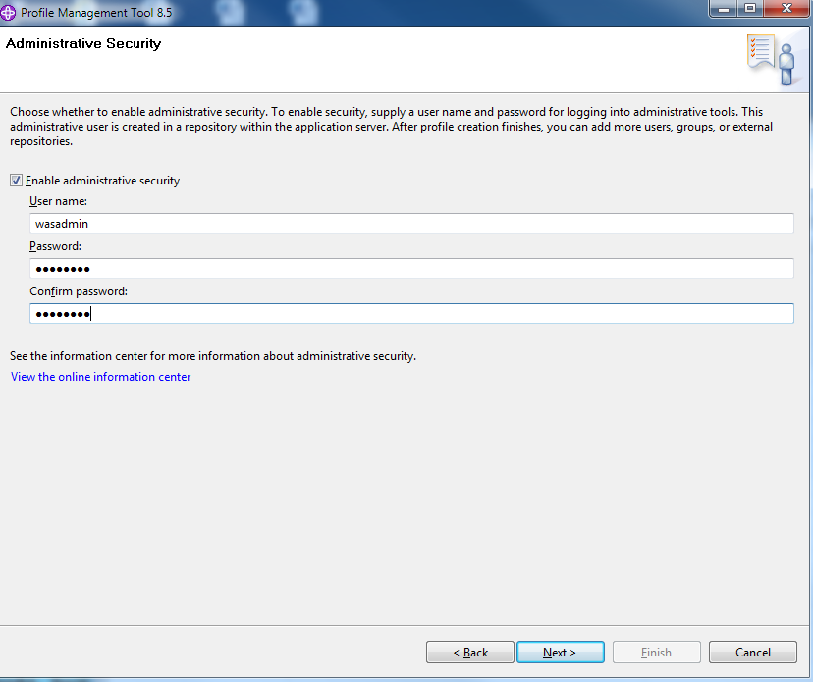

Enable administrative security,

* Username: wasadmin
* Password: wasadmin

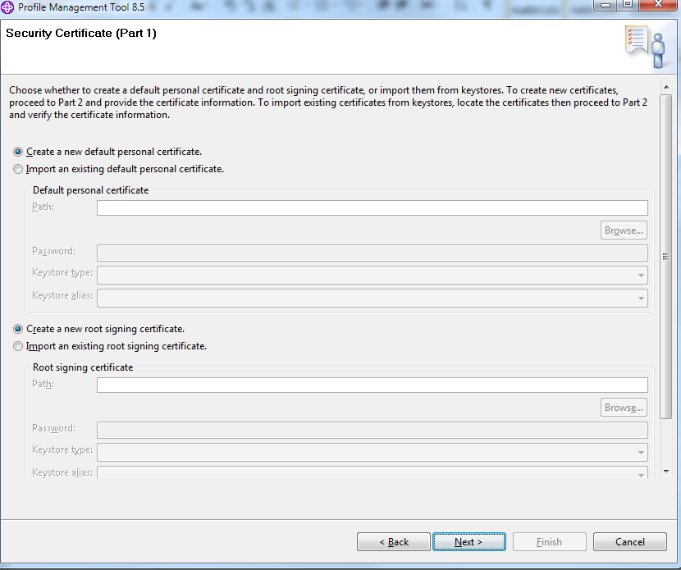

Security Certification:

To create new certifications and provide the certification information (To import existing certifications from keystores, locate the certificates and verify the certificate information)

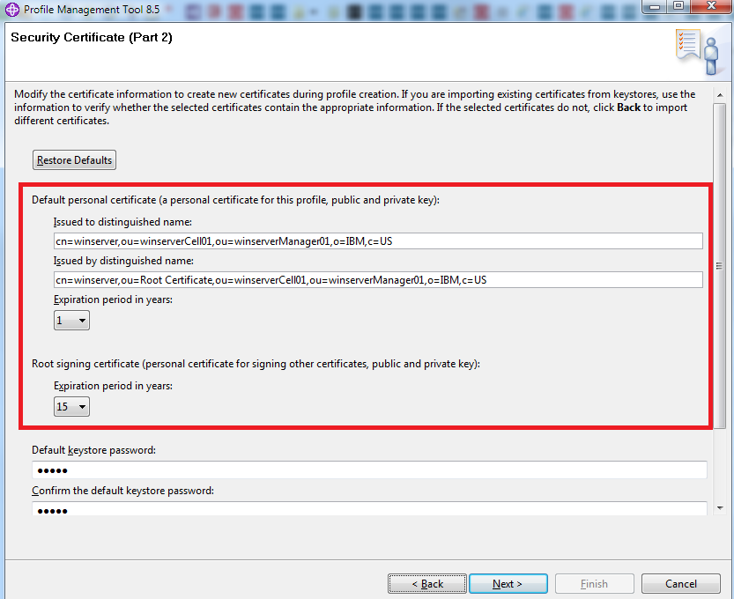

Default personal certificate (a personal certificate for this profile, public and private kwy)

Issued to distinguished name: cn=winserver,ou=winserverCell01,ou=winserverManager01,o=IBM,c=US

Issued by distinguished name: cn=winserver,ou=Root Certificate,ou=winserverCell01,ou=winserverManager01,o=IBM,c=US

Default keystore password: wasadmin

This password is well documented in the Information Center and should be changed to protect the keystore file and ssl configuration.

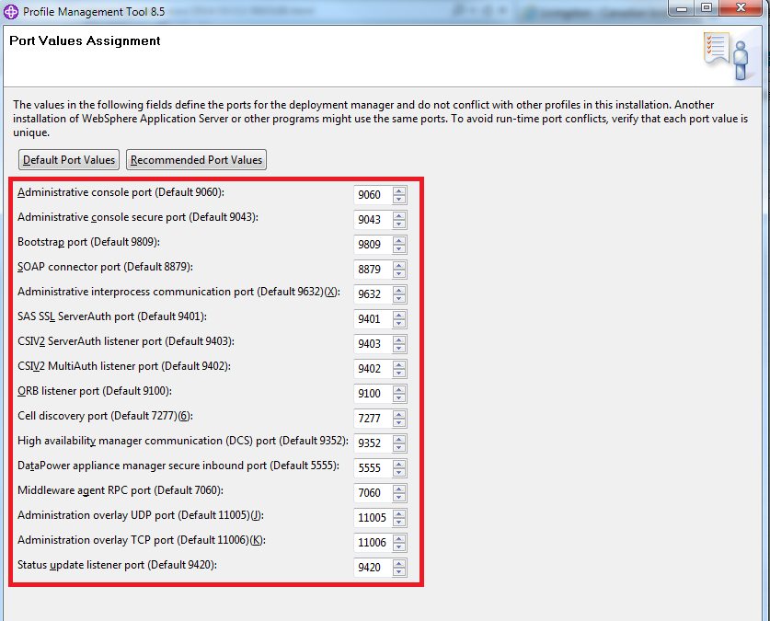

Secondly, we create two custom profiles on Windows and Linux,

Here we create a custom profile, which contains an empty node only (does not contain an administrative console or servers), the typical use for a custom profile is to federate this node to a deployment manager we implemented on Windows Server. After federating the node, use the deployment manager to create a server or a cluster of servers within the node.

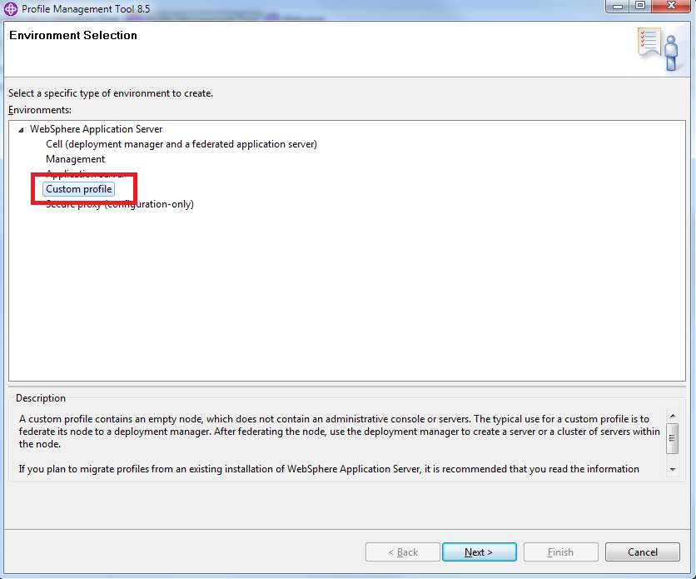

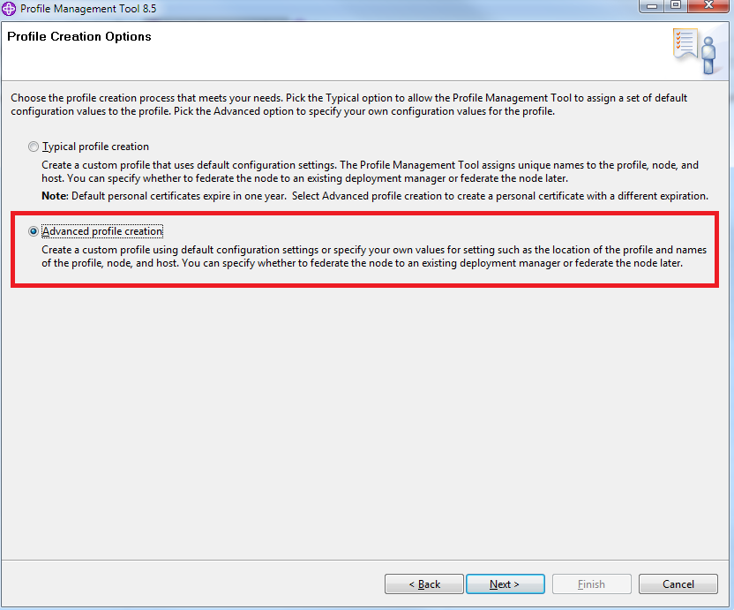

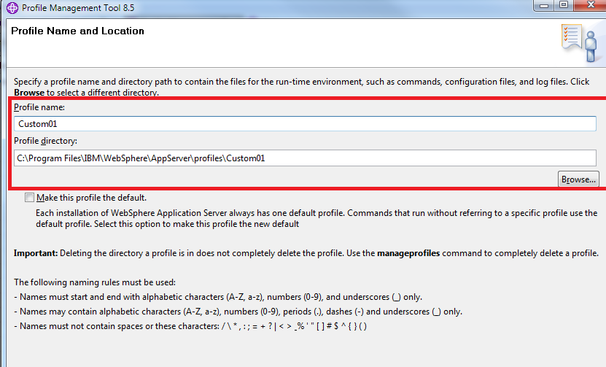

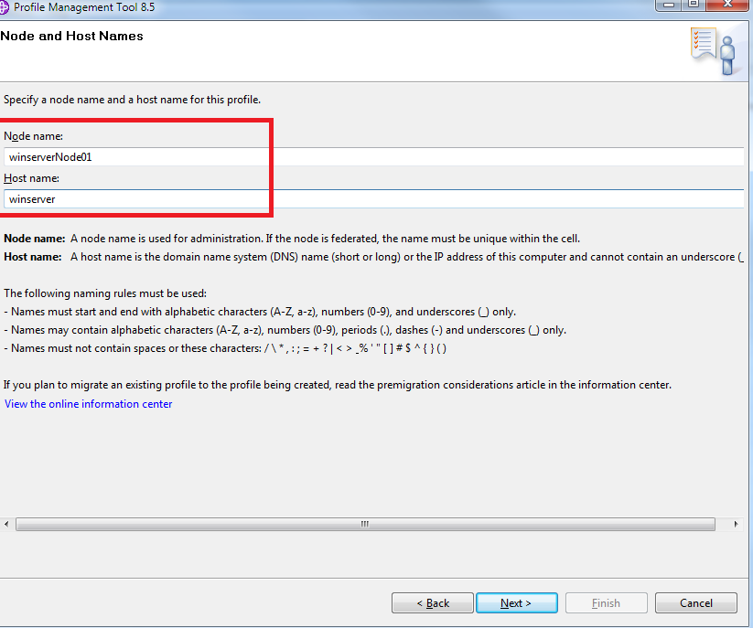

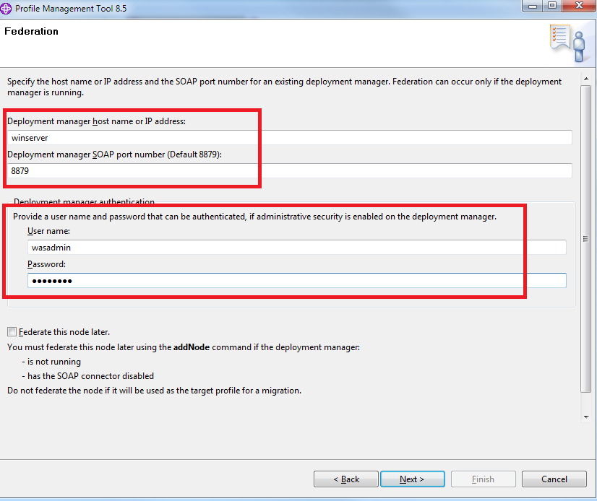

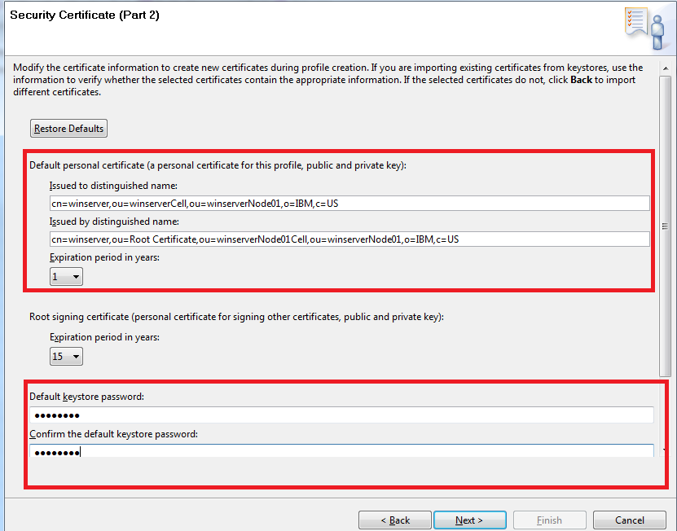

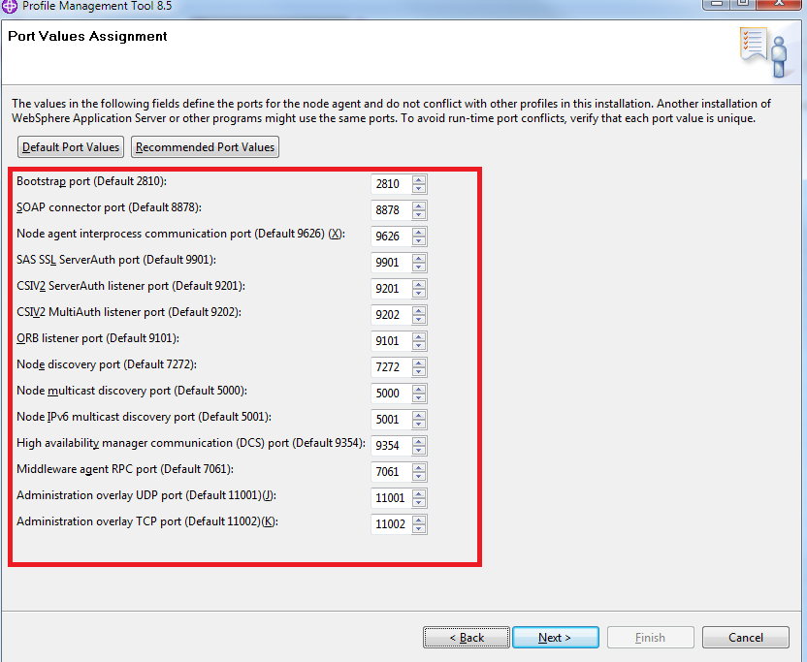

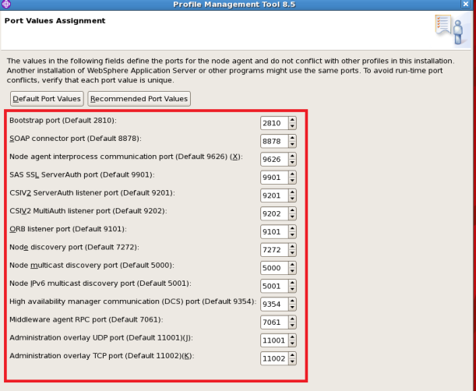

To create an application server:

profile name: AppSrv01

Node name: PCeClient

Server name: server1

Host name: winserver

(200M disk space needed)

Ports:

|  |  |
| --- | --- |
| Adm Console | 9061 |
| Adm Console sec | 9044 |
| HTTP | 9080 |
| HTTP Sec | 9443 |
| Bootstrap | 2809 |
| SIP | 5060 |
| SIP Sec | 5061 |
| SOAP connector | 8880 |
| Adm interprocess comm | 9633 |
| SAS SSL ServerAuth | 9406 |
| CSIV2 ServerAuth listener | 9405 |
| CSIV2 MutiAuth listener | 9404 |
| ORB listener port | 9102 |
| High availability manager comm | 9353 |
| Service integration | 7276 |
| Service integration Sec | 7286 |
| Service integration MQ interoperability | 5558 |
| Service integration MQ interoperability Sec | 5578 |
| Adm overlay UDP | 11003 |
| Adm overlay TCP | 11004 |

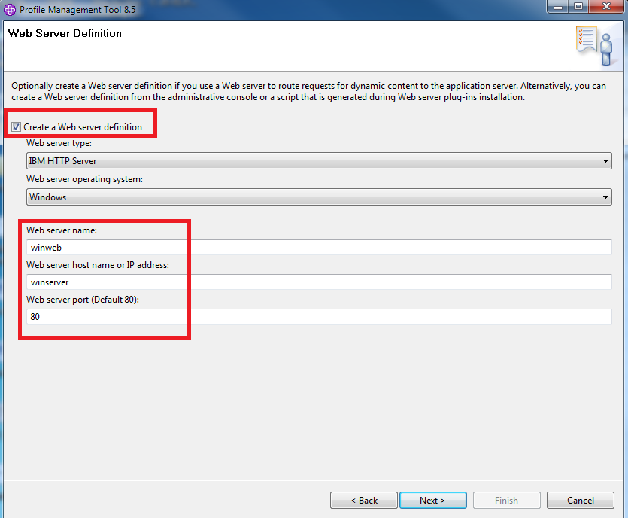

Install Web Server(c:\Program Files\IBM\HTTPServer) and Web Server plug-in(c:\Program Files\IBM\HTTPServer\Plugins)

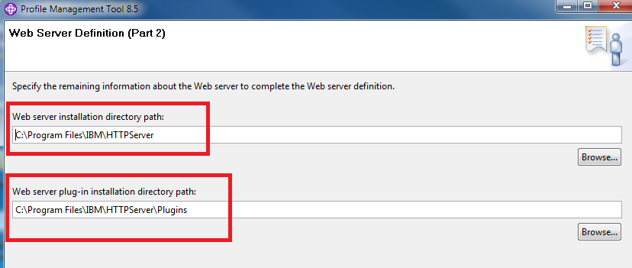

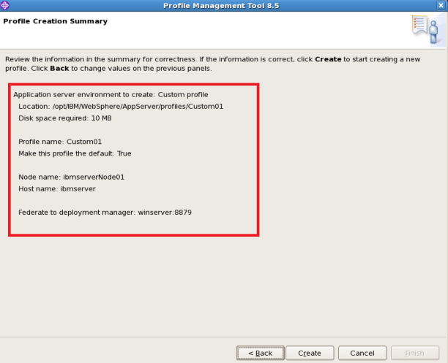

After creating Application profile, the next step is to decide whether to federate it into a deployment management cell. To federate application server, use either addNode command or the administrative console of deployment manager. Using the administrative console requires the application server to be running.

To install IBM HTTP server and Web server plug-ins for WebSphere Application Server

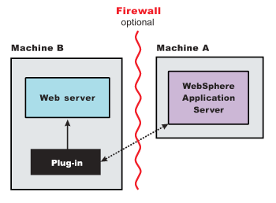

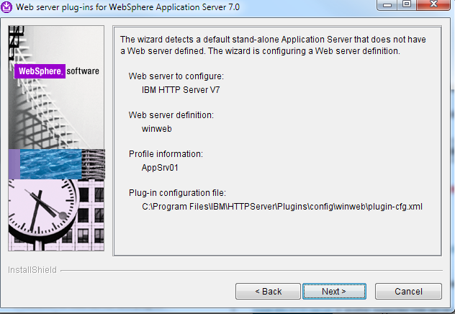

**Create Deployment Manager on Windows Server**

Production Deployment Manager installation/configuration sample:

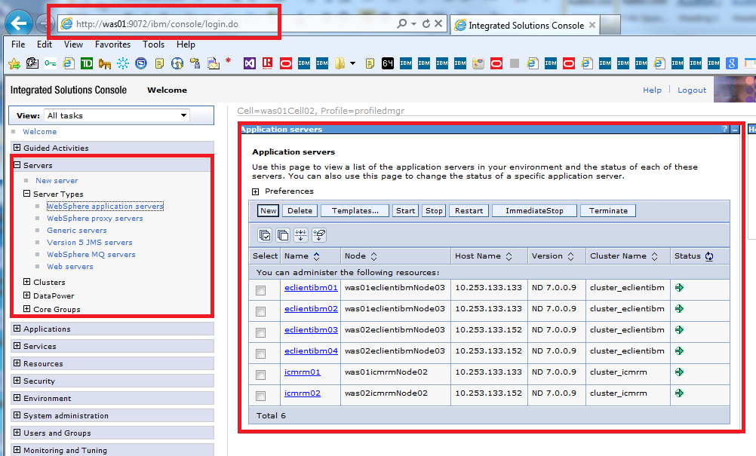

It’s also a good idea to choose Application Server, which will create an application server profile independently, then federate it to deployment manager.

## WAS Deployment Manager Profile ports Summary

|  |  |  |  |  |  |  |  |  |  |  |
| --- | --- | --- | --- | --- | --- | --- | --- | --- | --- | --- |
| Cell | was01Cell02 | | | | | winserverCell01 | | | | |
| Host Name |  |  |  |  |  | winserver | | | ibmserver | |
| Profiles | profiledmgr |  |  |  |  | Dmgr01 | Custom01 | | Custom01 | |
| Node agent | - |  |  |  |  | - | nodeagent | | nodeagent | |
| Node |  | was01eclientibmNode03 | was02eclientibmNode03 | was01icmrmNode02 | was02icmrmNode02 | winserverManager01 | winserverNode01 | | ibmserverNode01 | |
| Server Cluster |  |  |  |  |  |  |  | eClient |  | eClient |
| Application Server |  |  |  |  |  |  |  | wineClient |  | ibmeClient |
| CELL_DISCOVERY_ADDRESS | 7300 |  |  |  |  | 7277 |  |  |  |  |
| BOOTSTRAP_ADDRESS | 9810 | 2827 | 2826 | 2823 | 2822 | 9809 | 2810 | 9811 | 2810 | 9812 |
| IPC_CONNECTOR_ADDRESS | 9632 | 9627 | 9627 | 9626 | 9626 | 9632 | 9626 | 9635 | 9626 | 9636 |
| SOAP_CONNECTOR_ADDRESS | 8893 | 8898 | 8896 | 8894 | 8892 | 8879 | 8878 | 8882 | 8878 | 8883 |
| ORB_LISTENER_ADDRESS | 9107 | 9111 | 9108 | 9108 | 9106 | 9100 | 9101 | 9104 | 9101 | 9105 |
| SAS_SSL_SERVERAUTH_LISTENER_ADDRESS | 9438 | 9908 | 9908 | 9905 | 9905 | 9401 | 9901 | 9408 | 9901 | 9410 |
| CSIV2_SSL_MUTUALAUTH_LISTENER_ADDRESS | 9439 | 9214 | 9214 | 9210 | 9210 | 9402 | 9202 | 9409 | 9202 | 9411 |
| CSIV2_SSL_SERVERAUTH_LISTENER_ADDRESS | 9437 | 9213 | 9213 | 9209 | 9209 | 9403 | 9201 | 9410 | 9201 | 9412 |
| WC_adminhost | 9072 |  |  |  |  | 9060 |  | 9063 |  | 9064 |
| WC_adminhost_secure | 9055 |  |  |  |  | 9043 |  | 9082 |  | 9047 |
| WC_defaulthost |  |  |  |  |  |  |  | 9082 |  | 9083 |
| WC_defaulthost_secure |  |  |  |  |  |  |  |  |  | 9446 |
| DCS_UNICAST_ADDRESS | 9363 | 9371 | 9371 | 9366 | 9367 | 9352 | 9354 | 9356 | 9354 | 9357 |
| XDAGENT_PORT |  |  |  |  |  | 7060 | 7061 |  | 7061 |  |
| OVERLAY_UDP_LISTENER_ADDRESS |  |  |  |  |  | 11005 | 11002 | 11010 | 11002 | 11011 |
| OVERLAY_TCP_LISTENER_ADDRESS |  |  |  |  |  | 11006 | 11001 | 11011 | 11001 | 11013 |
| DataPowerMgr_inbound_secure | 5555 |  |  |  |  | 5555 |  |  |  |  |
| STATUS_LISTENER_ADDRESS |  |  |  |  |  | 9420 |  |  |  |  |
| NODE_DISCOVERY_ADDRESS |  | 7307 | 7300 | 7301 | 7296 |  | 7272 |  | 7272 |  |
| NODE_IPV6_MULTICAST_DISCOVERY_ADDRESS |  | 5012 | 5012 | 5008 | 5008 |  | 5001 |  | 5001 |  |
| NODE_MULTICAST_DISCOVERY_ADDRESS |  | 5013 | 5013 | 5009 | 5009 |  | 5000 |  | 5000 |  |
| SIP_DEFAULTHOST |  |  |  |  |  |  |  | 5062 |  | 5063 |
| SIP_DEFAULTHOST_SECURE |  |  |  |  |  |  |  | 5065 |  | 5066 |
| SIB_ENDPOINT_ADDRESS |  |  |  |  |  |  |  | 7279 |  | 7280 |
| SIB_ENDPOINT_SECURE_ADDRESS |  |  |  |  |  |  |  | 7288 |  | 7289 |
| SIB_MQ_ENDPOINT_ADDRESS |  |  |  |  |  |  |  | 5560 |  | 5561 |
| SIB_MQ_ENDPOINT_SECURE_ADDRESS |  |  |  |  |  |  |  | 5580 |  | 5581 |

**Application server ports definition location:** /opt/IBM/WebSphere/AppServer/profiles/AppSrv01/properties/portdef.props

## Create a WAS server cluster

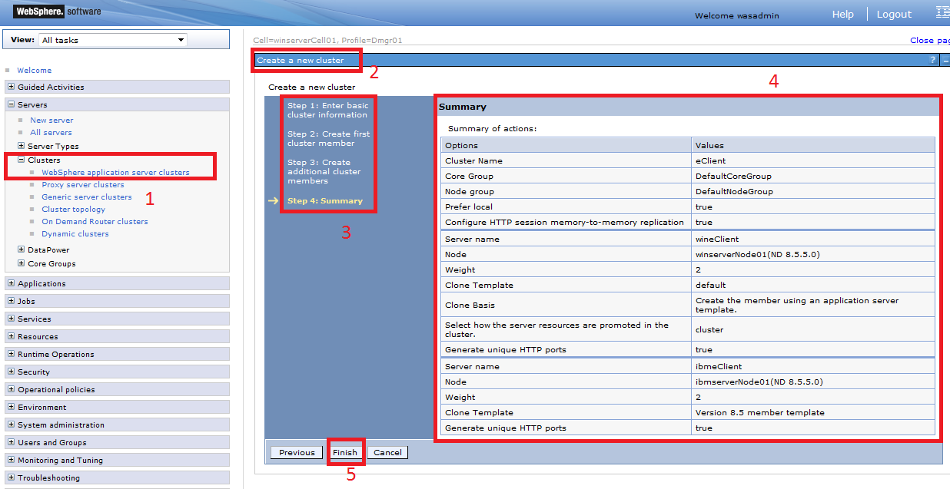

## Start nodeagent from WAS deployment manager

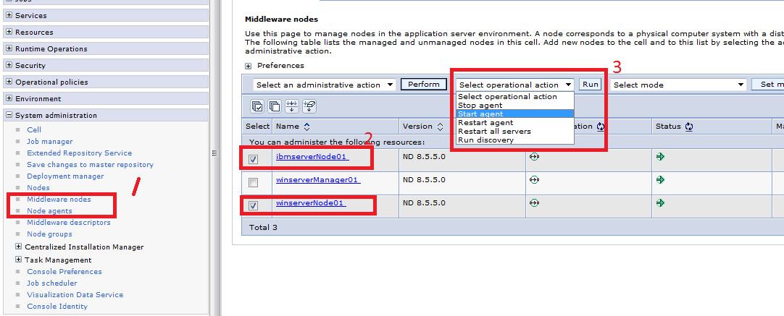

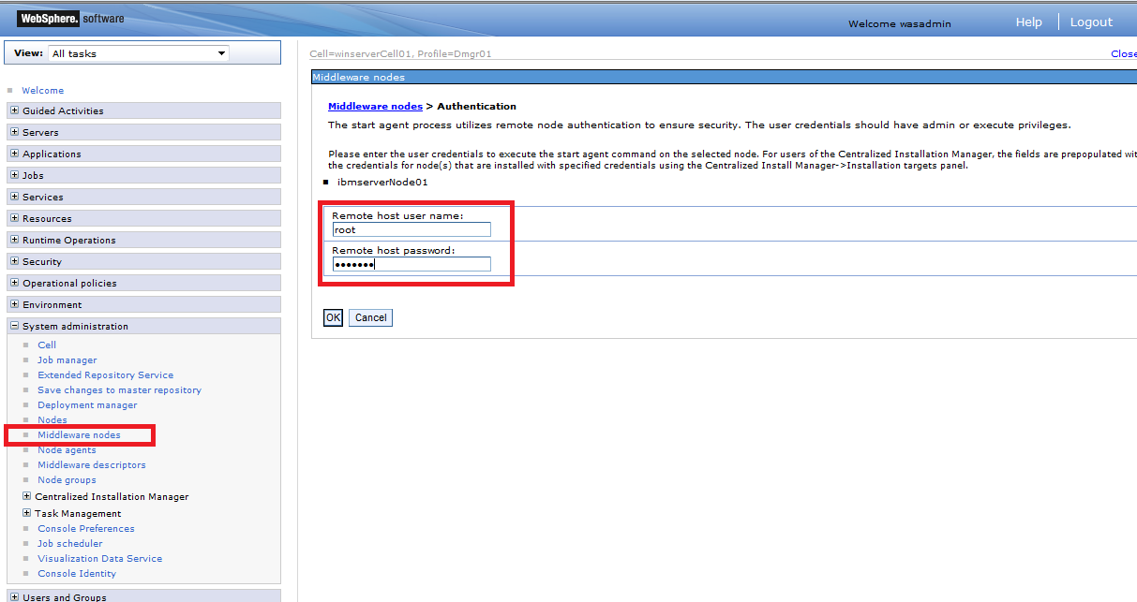

Start Remote register to enable remote users to modify registry setting on windows, if you need WAS deployment manager to start your nodeagent on windows:

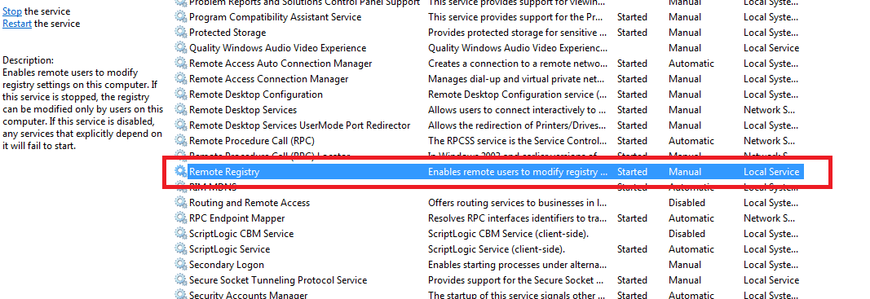

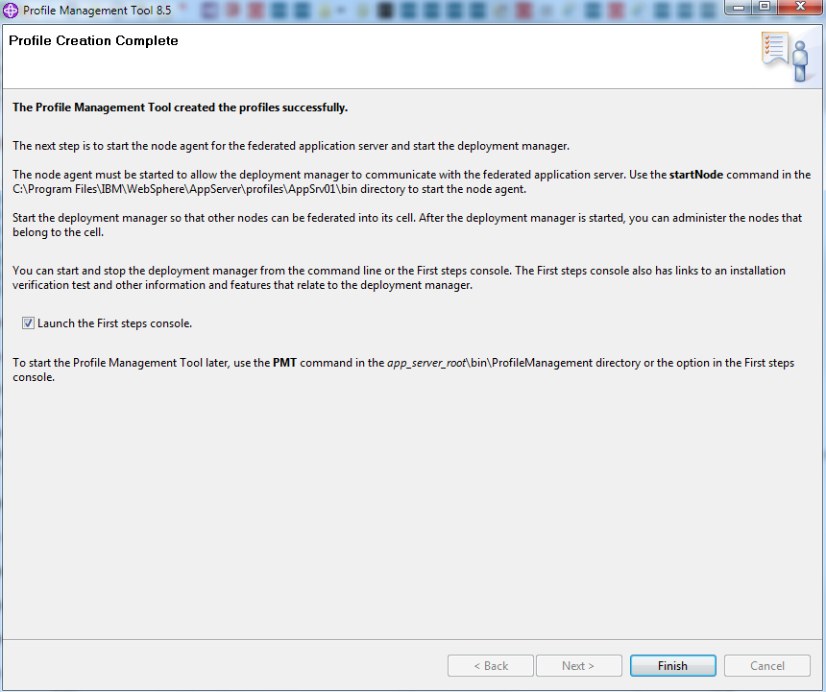

Node agent must be started to allow the deployment manager to communicate with federated application server, the **startNode** command lies in WAS installed profiles bin directory.

Deployment manager can be started from command line

Start running the following command:

cmd.exe /c "C:\Program Files\IBM\WebSphere\AppServer\profiles\Dmgr01\bin\startManager.bat" -profileName Dmgr01

First Step Console.

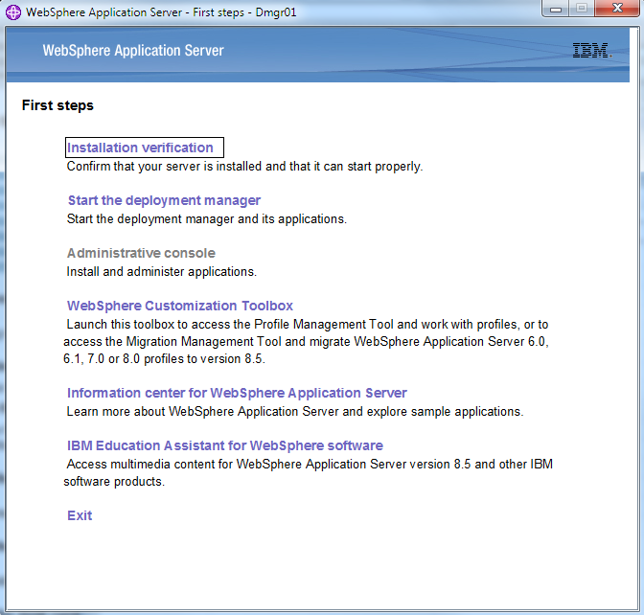

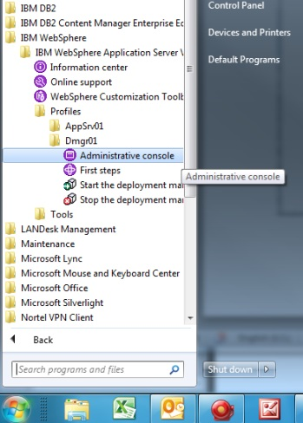

Start Administrative console of Deployment Manager

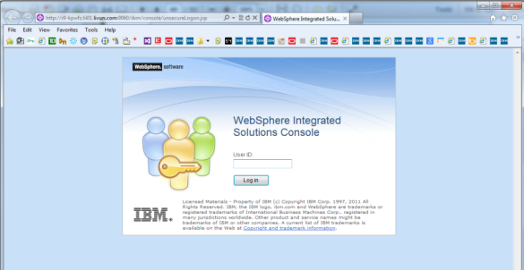

No user name/password needed here, because we choose “Not enable administrative security” when creating DM profile.

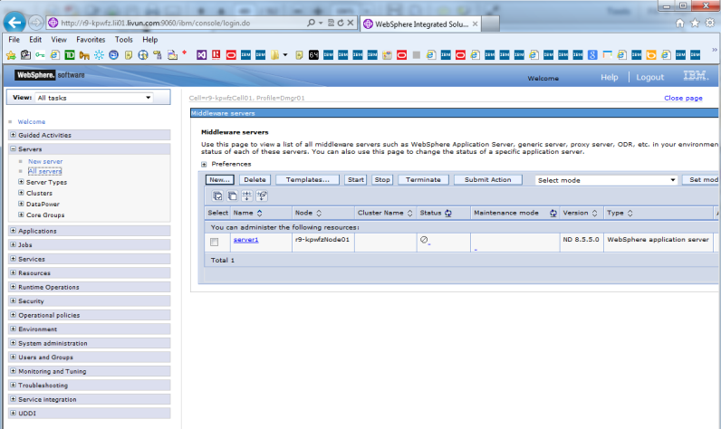

Here you can find the federated WAS Server ***server1*** under the Cell ***r9-kpwfzCell01***, with unknown status. You need to start Node agent of ***server1***,

Located under C:\Program Files\IBM\WebSphere\AppServer\profiles\AppSrv01\bin\startNode.bat

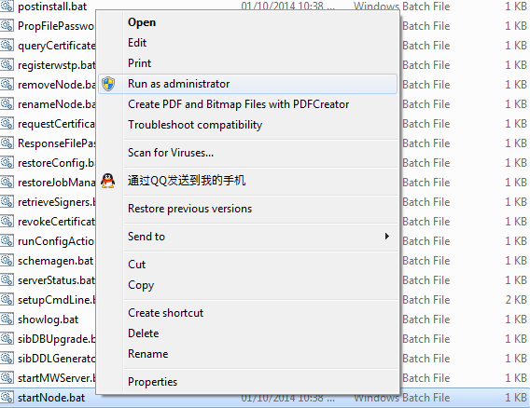

Then, you can see the status of server1, and start this federated WAS server if you want

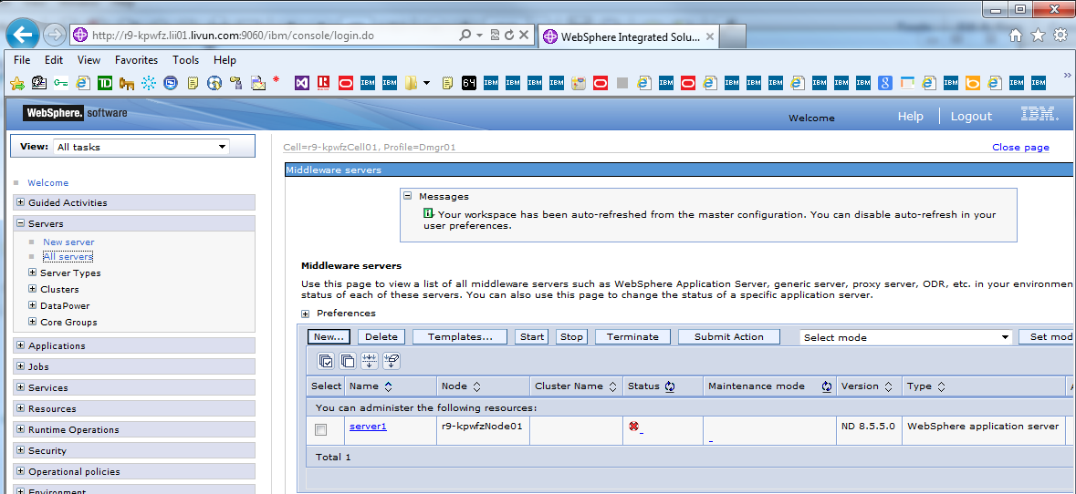

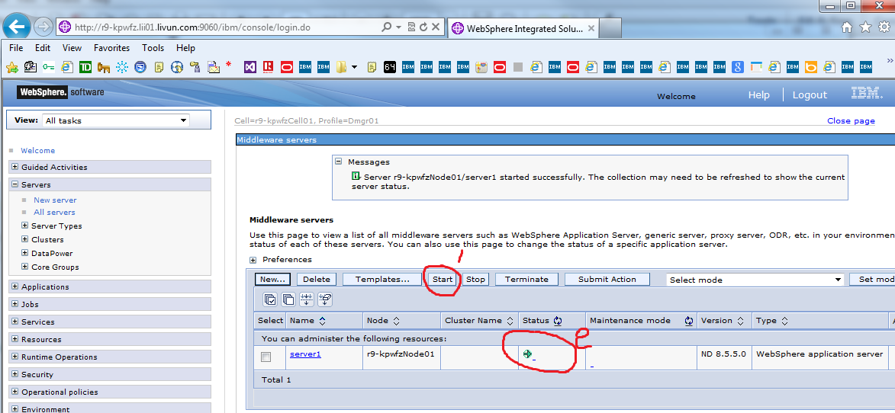

**Federate a stand-alone application server**

To federate WAS server to Deploy Manager Server; we need to add WAS node

Firstly, on deployment manager, add one WAS node installed on Window Server r9-wkpfz.

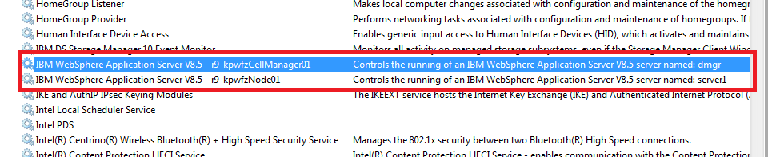

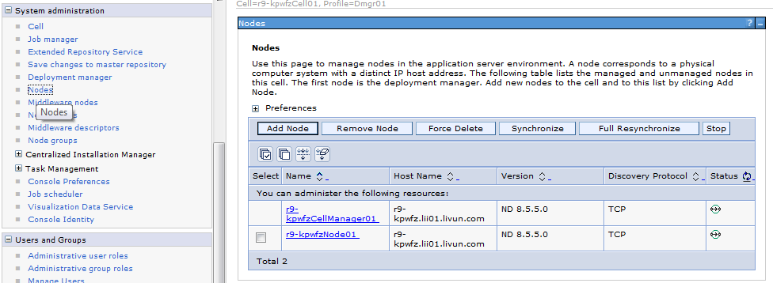

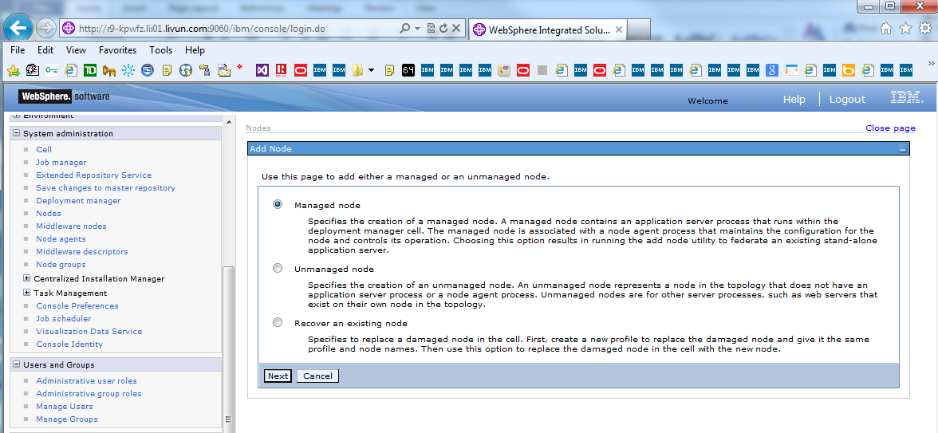

Choose Managed Node: Specifies the creation of a managed node. A managed node contains an application server process that runs within the deployment manager cell. The managed node is associated with a node agent process that maintains the configuration for the node and controls its operation.

Choosing this option results in running the add node utility to **federate an existing stand-alone application server.**

On Window Server, We install Deploy Manager Server running as a windows service, and one WAS Server running as windows service,

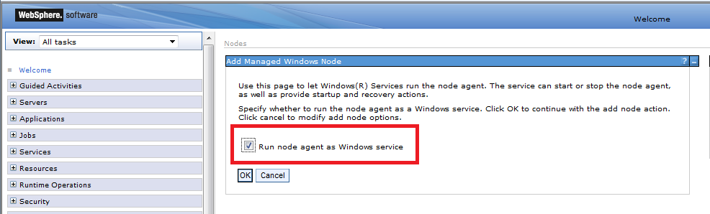

Check “Run node agent as Windows Service”

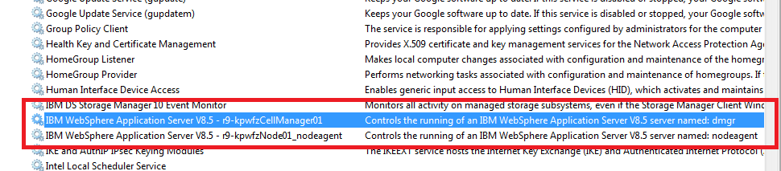

You will find that WebSphere Application Server Service replaced by WebSphere Application Server’s nodeagent service.

TIPS: For the installation of WAS and IBM CM on Linux, please reference “LMS System Administrative Manual”

Secondly, add another Linux WAS Server to Deployment Server, Start WAS Server’s node agent and Server processes:

Start WAS Server on Linux: Use GUI or Command Line:

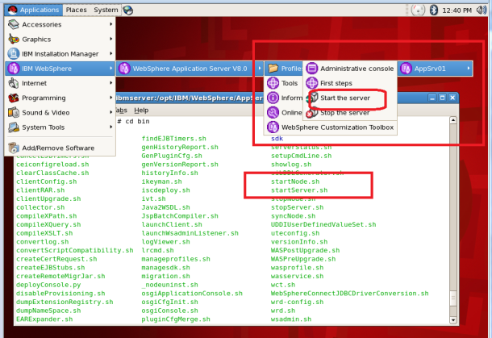

[root@ibmserver bin]# **./startNode.sh**

ADMU0116I: Tool information is being logged in file

/opt/IBM/WebSphere/AppServer/profiles/AppSrv01/logs/nodeagent/startServer.log

ADMU0128I: Starting tool with the AppSrv01 profile

ADMU3100I: Reading configuration for server: nodeagent

ADMU3200I: Server launched. Waiting for initialization status.

ADMU3000I: Server nodeagent open for e-business; process id is 16212

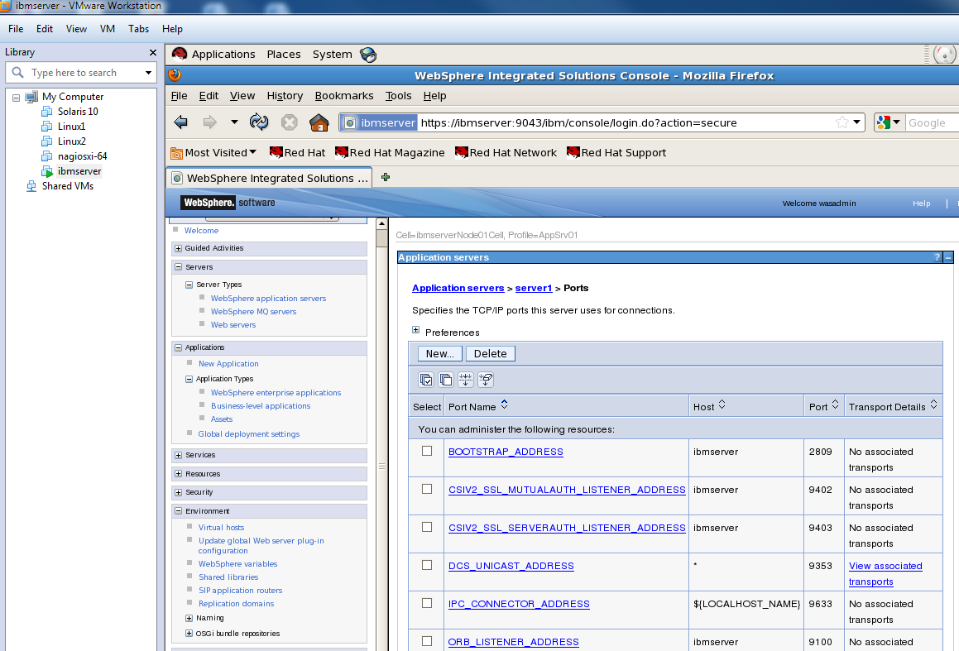

Check the WAS server’s ports information on Linux stand-alone WAS Server, when installing, we use default value.

On Deployment Manager Console, add managed node:

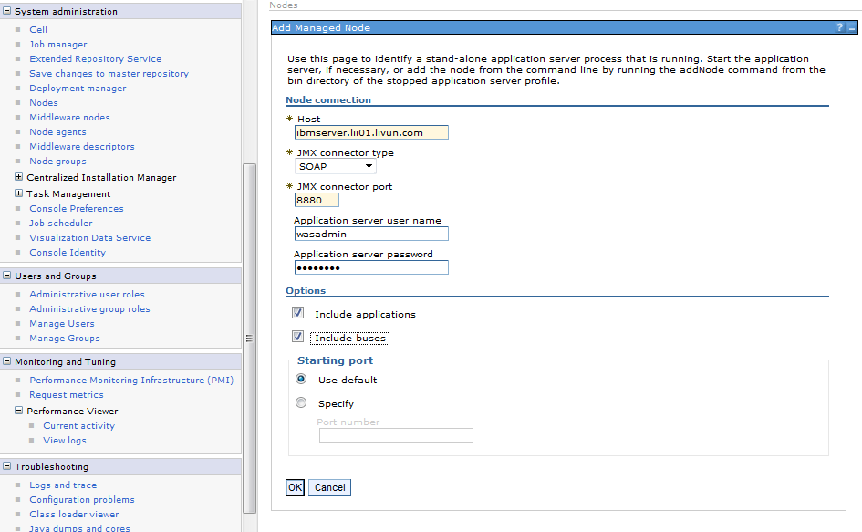

Host: ***ibmserver.lii01.livun.com***

JMX connector type: ***SOAP***

JMX connector port: ***8880***

Application server user name: ***wasadmin***

Application server password: ***wasadmin***

Option: ***Include application and Include buses***

TIPS: Please be advised that the federated WAS Application server must started on Linux, and host name must be defined on DNS and/or local /etc/hosts on all systems.

**Adding node**

ADMU0001I: Begin federation of node ibmserverNode01 with Deployment Manager at r9-kpwfz.lii01.livun.com:8879.

ADMU0009I: Successfully connected to Deployment Manager Server: r9-kpwfz.lii01.livun.com:8879

ADMU0505I: Servers found in configuration:

ADMU0506I: Server name: webserver1

ADMU0506I: Server name: server1

ADMU2010I: Stopping all server processes for node ibmserverNode01

ADMU0510I: Server server1 is now STOPPED

ADMU0024I: Deleting the old backup directory.

ADMU0015I: Backing up the original cell repository.

ADMU0012I: Creating Node Agent configuration for node: ibmserverNode01

ADMU0120I: isclite.ear will not be uploaded since it already exists in the target repository.

ADMU0120I: commsvc.ear will not be uploaded since it already exists in the target repository.

ADMU0120I: DefaultApplication.ear will not be uploaded since it already exists in the target repository.

ADMU0120I: ibmasyncrsp.ear will not be uploaded since it already exists in the target repository.

ADMU0120I: WebSphereWSDM.ear will not be uploaded since it already exists in the target repository.

ADMU0120I: DefaultApplication.ear will not be uploaded since it already exists in the target repository.

ADMU0014I: Adding node ibmserverNode01 configuration to cell: r9-kpwfzCell01

ADMU0120I: commsvc on CU will not be uploaded since it already exists in the target repository.

ADMU0120I: WebSphereWSDM on CU will not be uploaded since it already exists in the target repository.

ADMU0120I: ibmasyncrsp on CU will not be uploaded since it already exists in the target repository.

ADMU0120I: isclite on CU will not be uploaded since it already exists in the target repository.

ADMU0120I: DefaultApplication on CU will not be uploaded since it already exists in the target repository.

ADMU0120I: commsvc on BLA will not be uploaded since it already exists in the target repository.

ADMU0120I: WebSphereWSDM on BLA will not be uploaded since it already exists in the target repository.

ADMU0120I: ibmasyncrsp on BLA will not be uploaded since it already exists in the target repository.

ADMU0120I: isclite on BLA will not be uploaded since it already exists in the target repository.

ADMU0120I: DefaultApplication on BLA will not be uploaded since it already exists in the target repository.

ADMU0016I: Synchronizing configuration between node and cell.

ADMU0018I: Launching Node Agent process for node: ibmserverNode01

ADMU0020I: Reading configuration for Node Agent process: nodeagent

ADMU0022I: Node Agent launched. Waiting for initialization status.

ADMU0030I: Node Agent initialization completed successfully. Process id is: 8076

ADMU0308I: The node ibmserverNode01 and associated applications were successfully added to the r9-kpwfzCell01 cell.

ADMU0306I: Note:

ADMU0302I: Any cell-level documents from the standalone r9-kpwfzCell01 configuration have not been migrated to the new cell.

ADMU0307I: You might want to:

ADMU0303I: Update the configuration on the r9-kpwfzCell01 Deployment Manager with values from the old cell-level documents.

ADMU0003I: Node ibmserverNode01 has been successfully federated.

[**View the available nodes.**](http://r9-kpwfz.lii01.livun.com:9060/ibm/console/navigatorCmd.do?csrfid=-538489563&forwardName=Node.content.main)

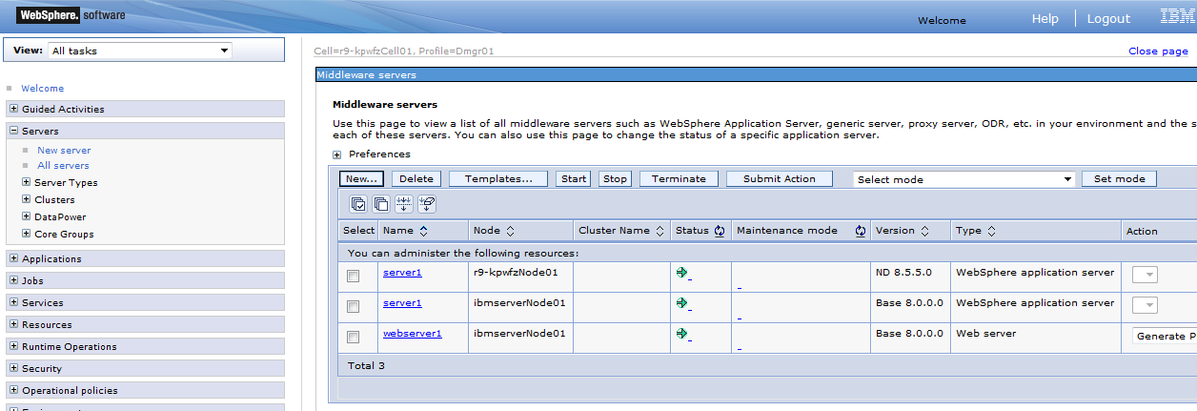

**Create Cluster**

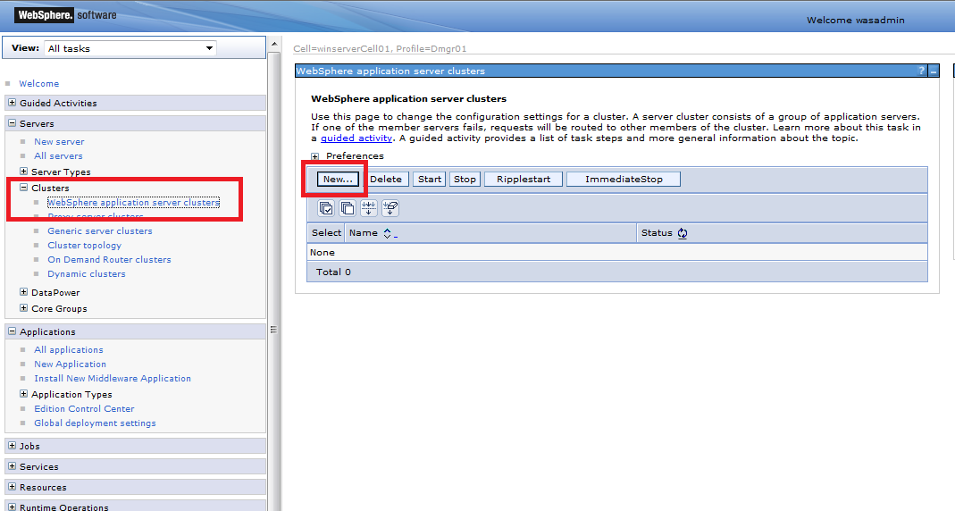

A server cluster consists of a group of application servers. If one of the member servers fails, requests will be routed to other members of the cluster.

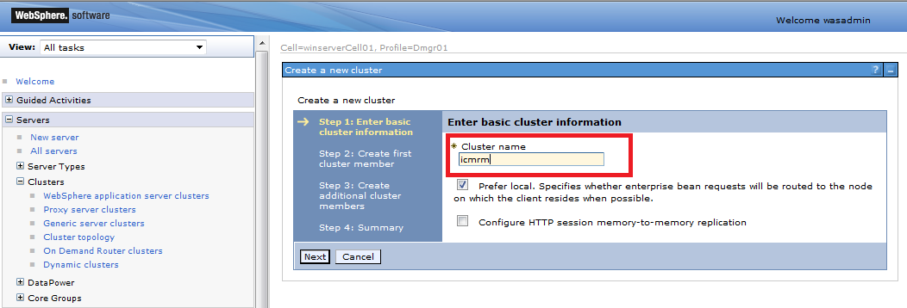

Cluster name: icmrm

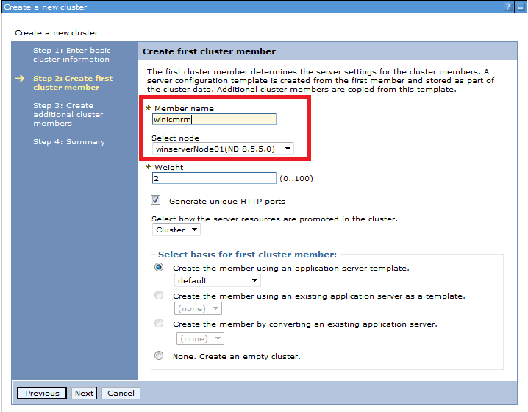

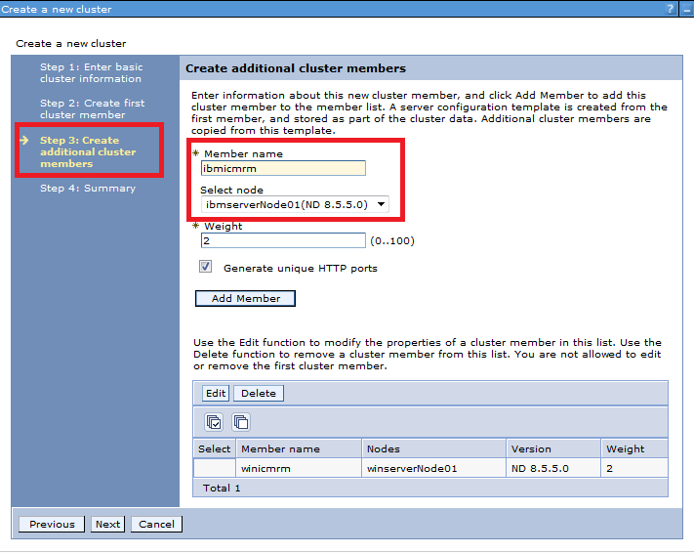

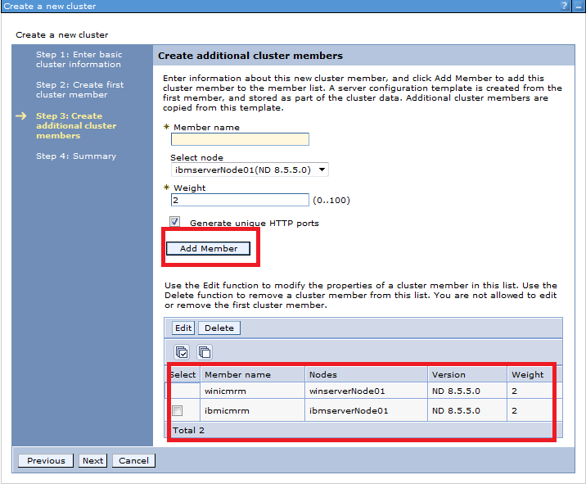

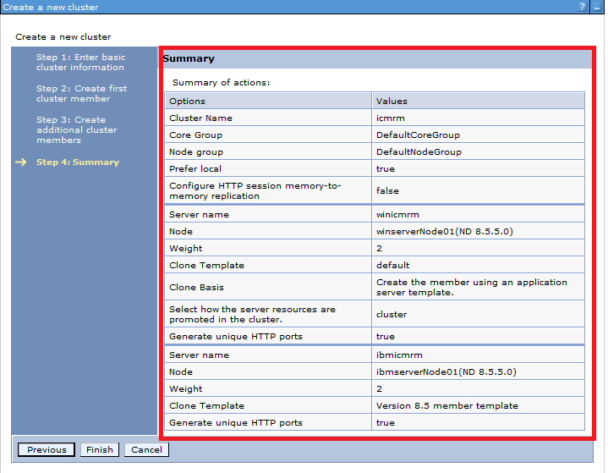

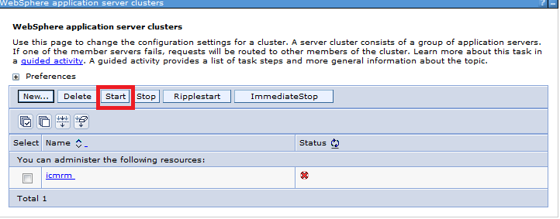

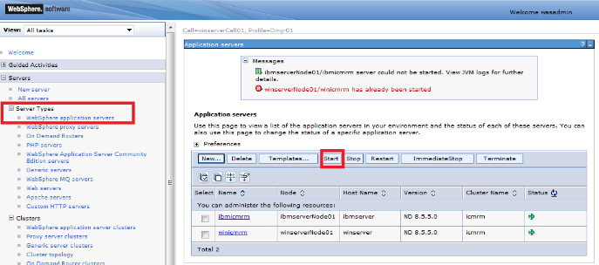

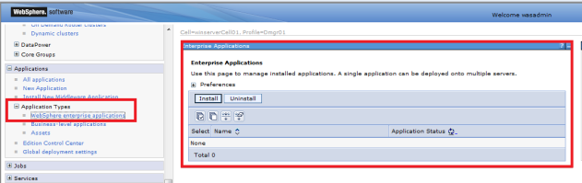

The first cluster member determines the server setting for the cluster members. A server configuration template is created from the first member and stored as part of the cluster data.

Additional cluster members are copied from the template.

The basis for the first cluster member is created by converting an existing application server:

***r9-kpwfzCell01/ibmserverNode01(base 8.0.0.0)/server1***

Create additional cluster members:

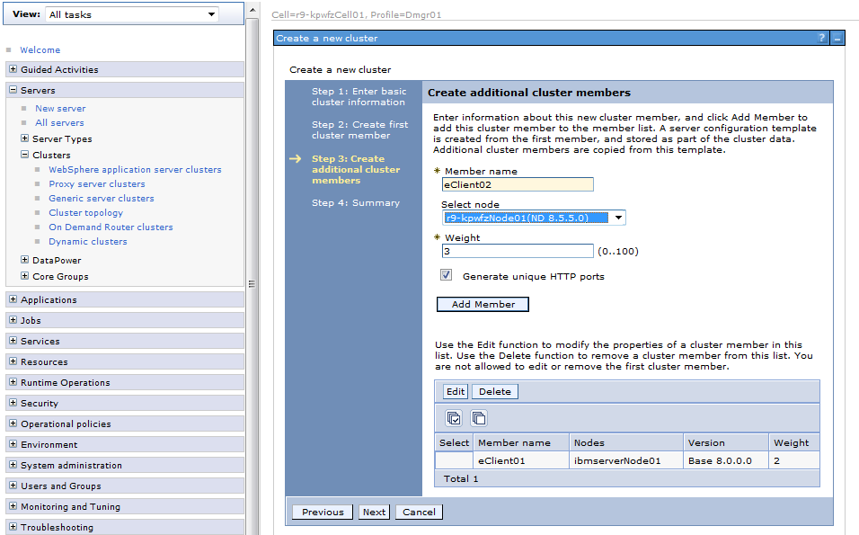

A server configuration template is created from the first member, and store as part of the cluster data. Additional cluster members are copied from the template.

Member name: eClient02

Node: r9-kpwfzNode01(ND 8.5.5.0)

Wright: 3

Generate unique HTTP ports

Summary:

|  |  |  |
| --- | --- | --- |
| Server name | eClient01 | eClient02 |
| Node | ibmserverNode01 | r9-kpwfzNode02 |
| Weight | 2 | 3 |
| Clone Template | r9-kpwfzCell01/ibmserverNode01/server1 | Version 8.5 member template |
| Clone Basis | Create the member using existing application server as a template |  |
| Select how the server resources are promoted in the cluster | cluster |  |
| Generate unique HTTP ports | true | true |
|  |  |  |

Start the DB2 database server, and start WebSphere Application Server/Cluster before install IBM Content Manager.

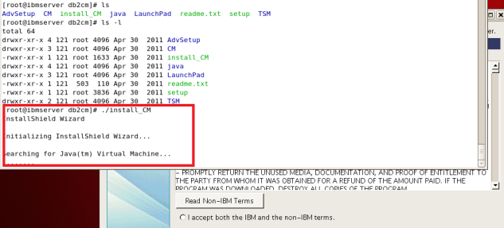

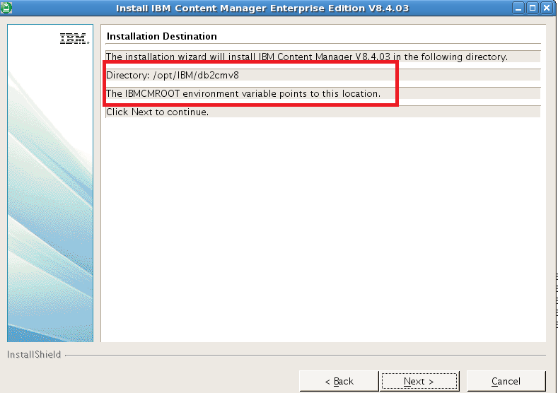

Install IBM Content Manager Components

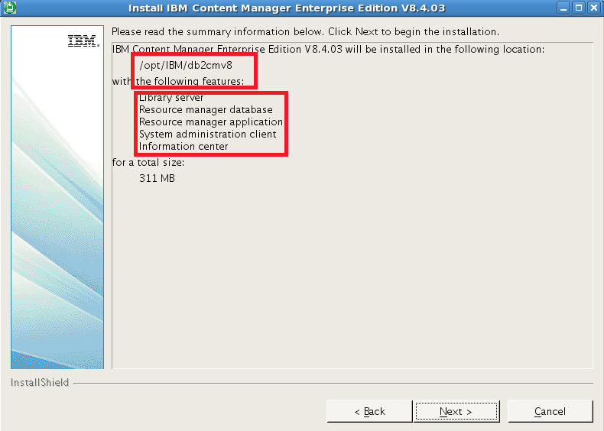

Configure IBM Content Manager Components

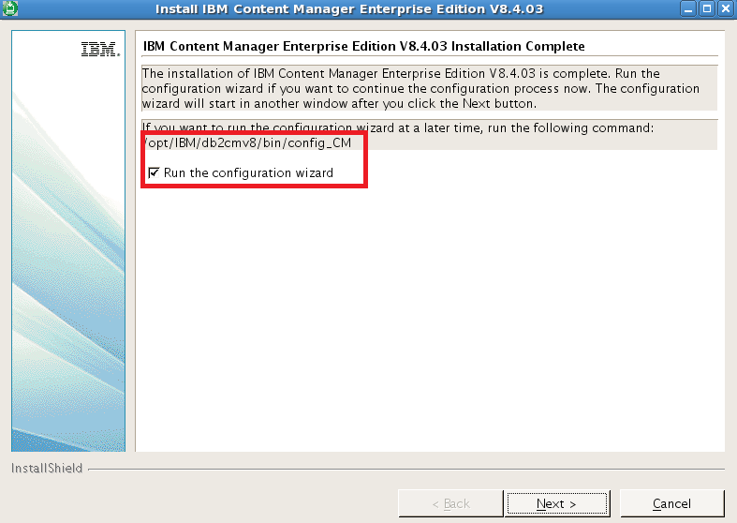

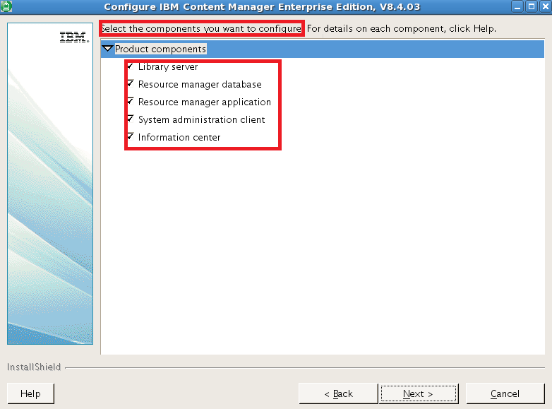

\

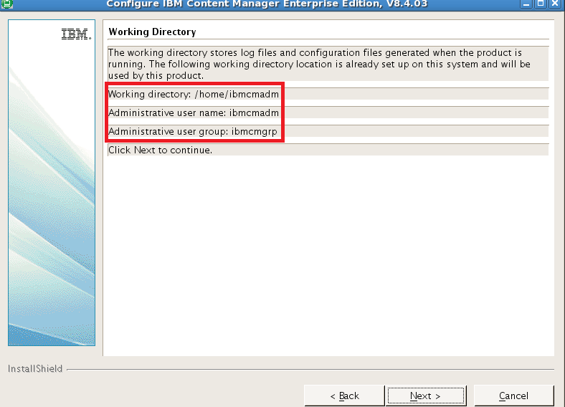

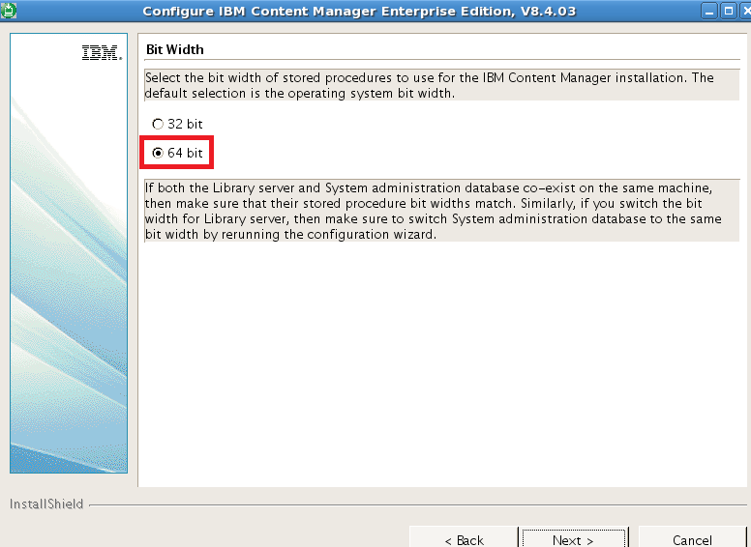

Create database (if it’s first CM installation) or using exist database (icmnlsdb/rmdb)

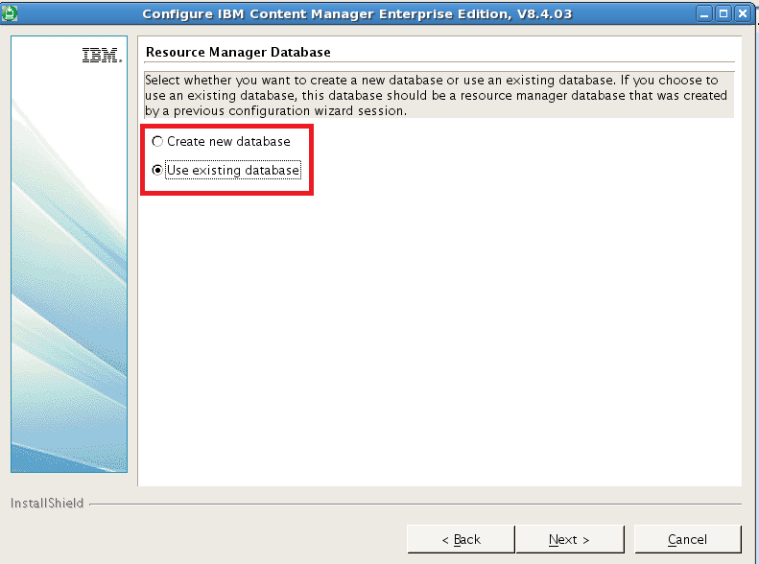

Install resource manager application (java beans) on /opt/IBM/db2cmv8

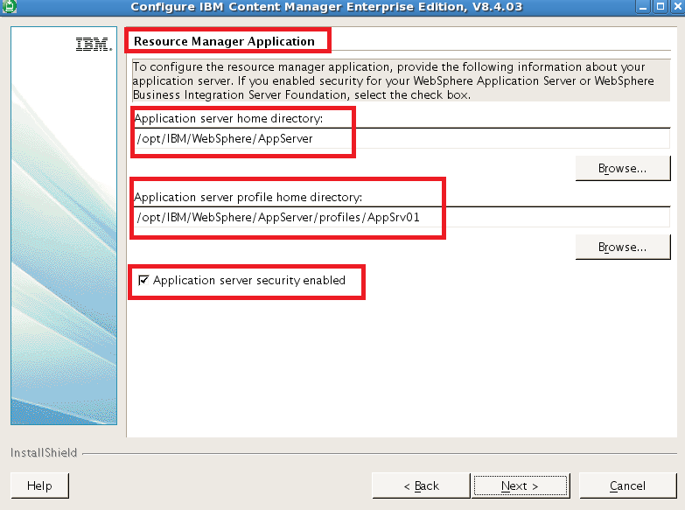

In this case, WAS application server security is not enabled. (It’s defined during WAS Application server profile creating process)

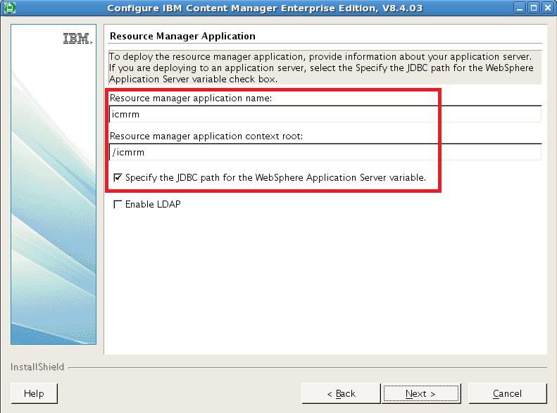

Resource manager application name and context root in WAS Server1

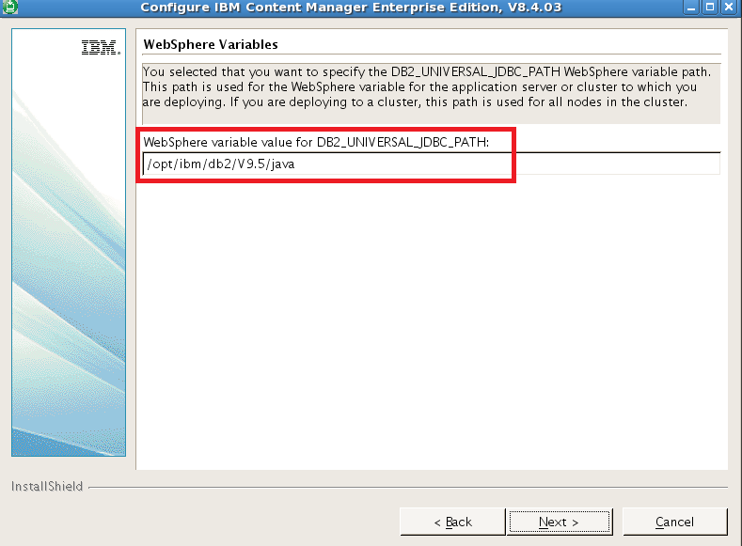

Define WebSphere Variable for DB2_UNIVERSAL_JDBC_PATH, it’s used for JDBC definition and same for all nodes if you are using cluster.

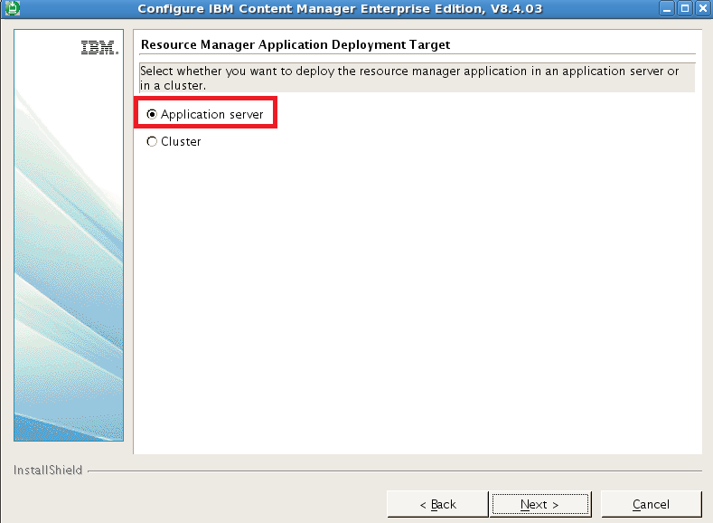

WAS node name and server name

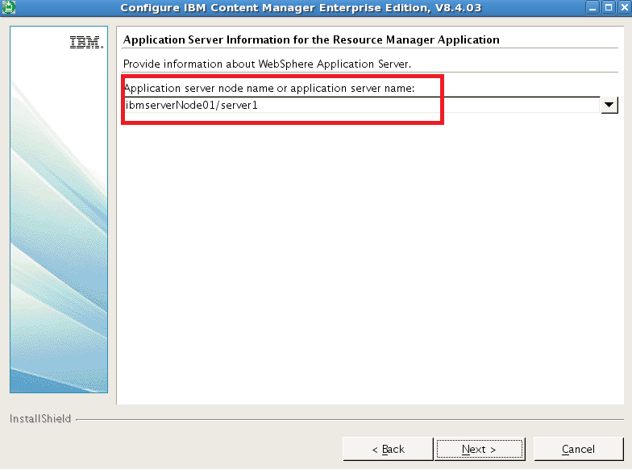

HTTP connect information for CM Resource Manager

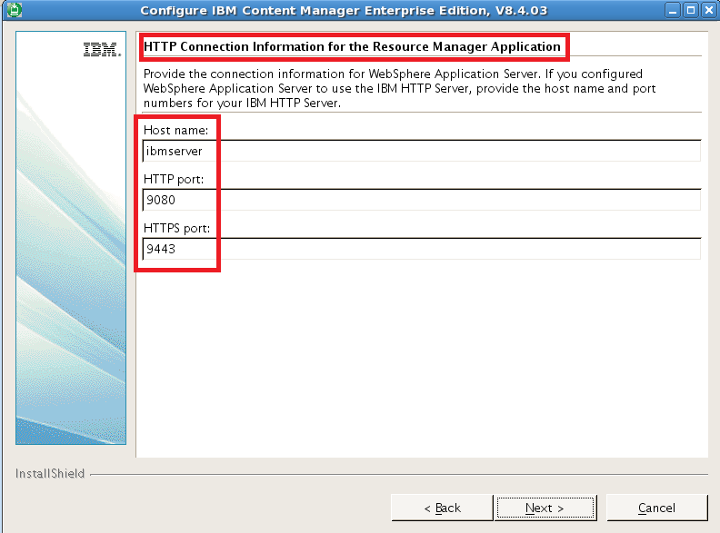

HTTP Port: 9080/HTTPS: 9443

CM Storage definition

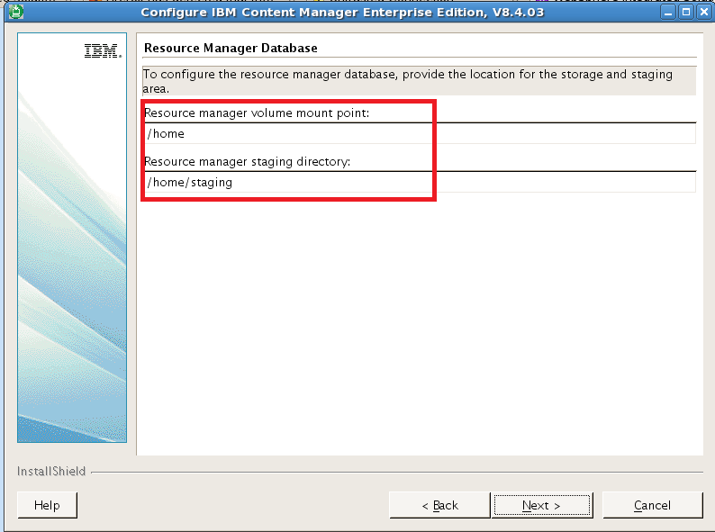

System Administration Client installation and configuration

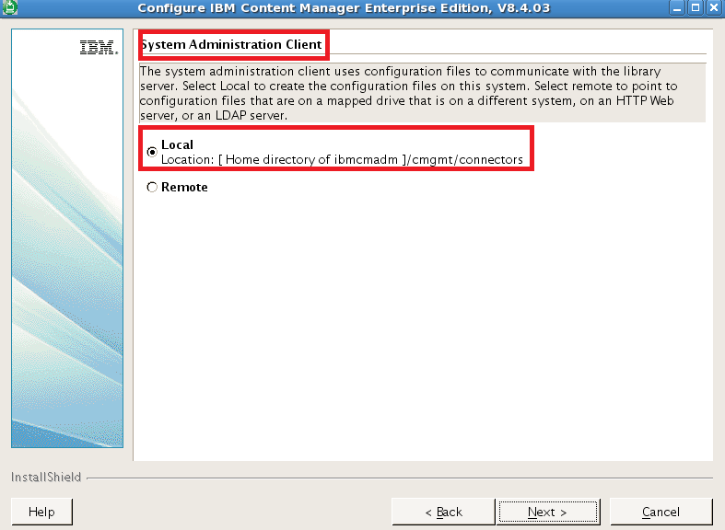

Using same configuration file of CM user ibmcmadm: /home/ibmcmadm/cmgmt/connectors

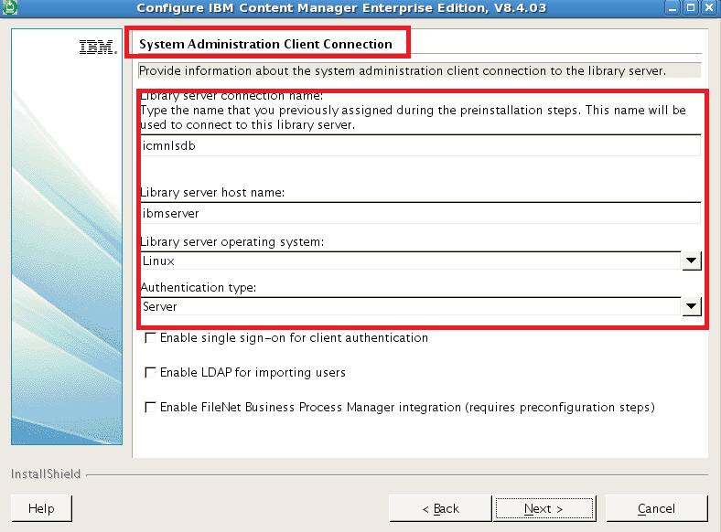

System Administration Client connections

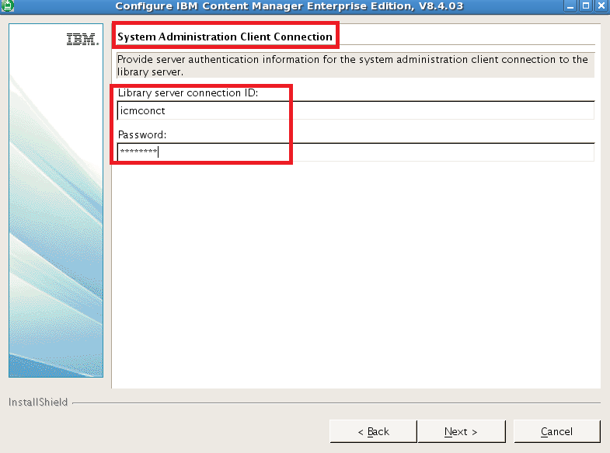

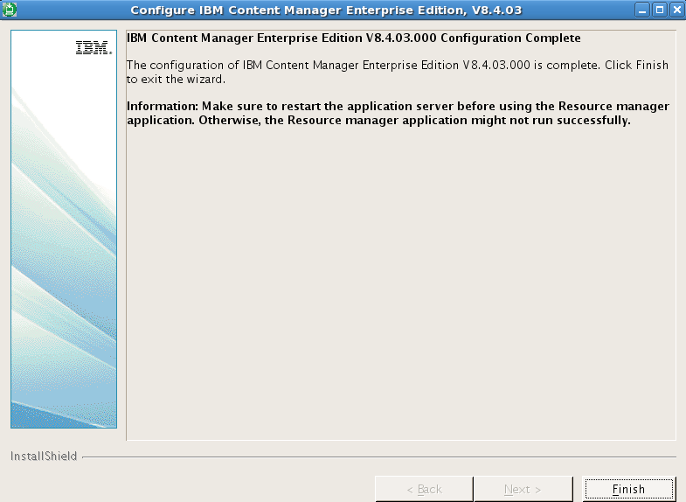

Installation finished

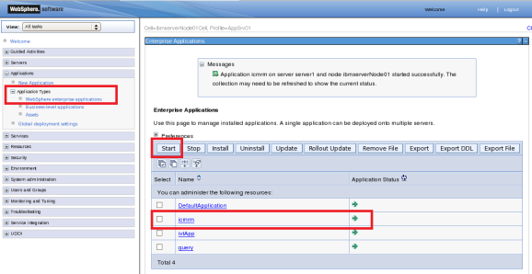

Start icmrm on WAS

Connect to IBM Content Manager Resource manager

<https://ibmserver:9443/icmrm> (login will fail?, have to change ibmserver to localhost)

<https://localhost:9443/icmrm/admin/jsf/login.jsp>

For https connection, just accept this certification issued by ibmserver/server1 on your web browser (IE, Firefox, etc.).

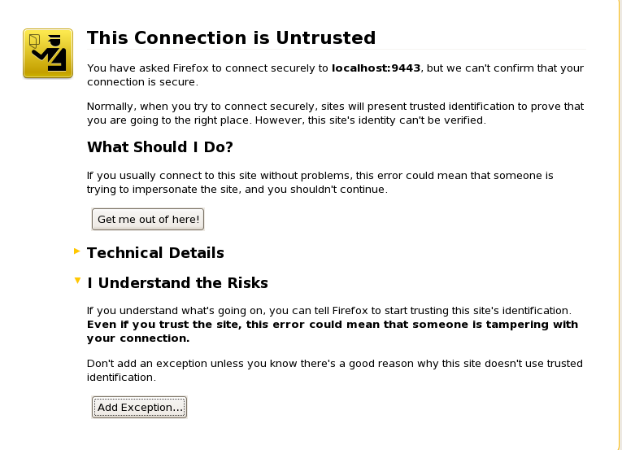

For FireFox, install certification:

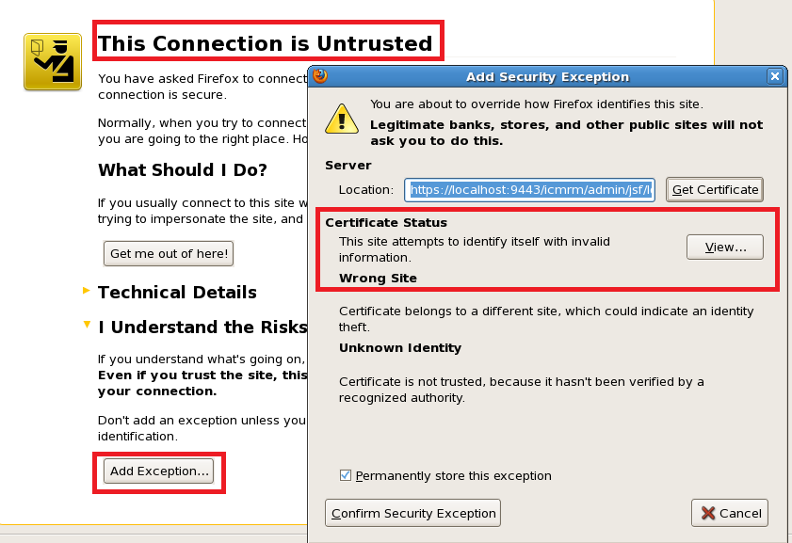

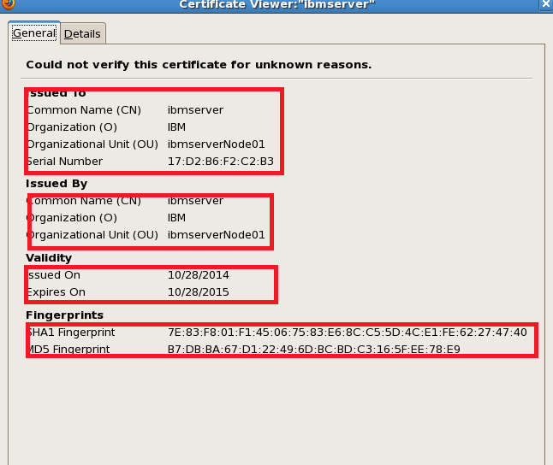

For IE, viewer certification

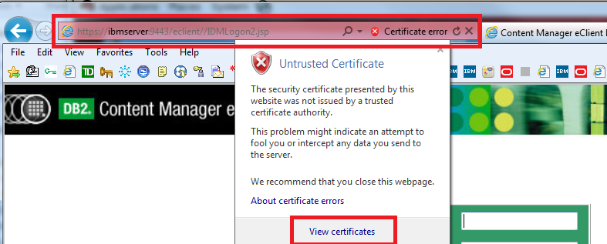

Install Certification

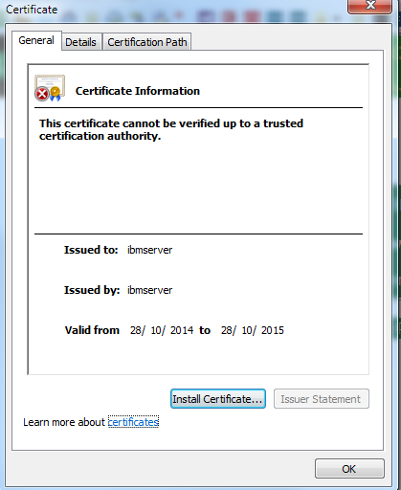

If you don’t want warning messages from your browser, you have to install and trust the certification from the website you use https protocol to connect to.

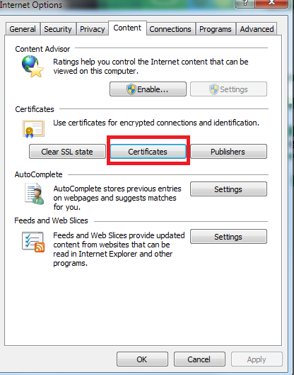

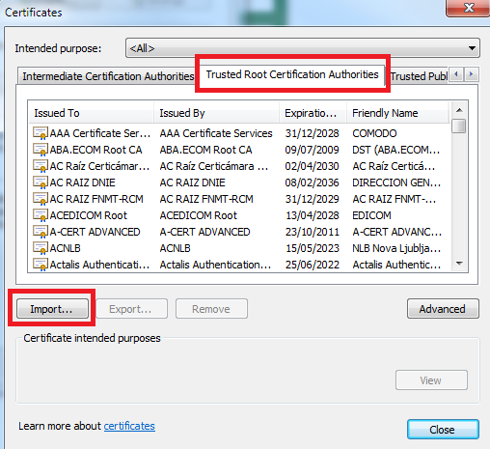

Import the certification you got from the website you visited.

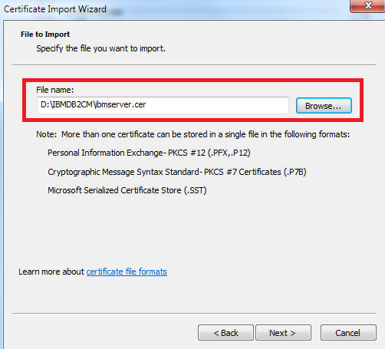

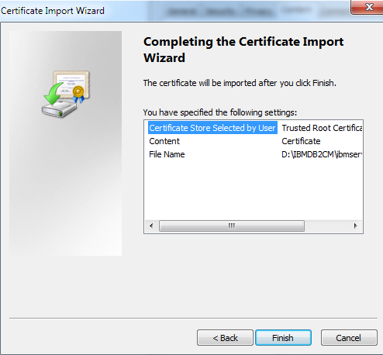

Finish certification installation and check the Thumbprint with your website service provider, make sure it from the right website.

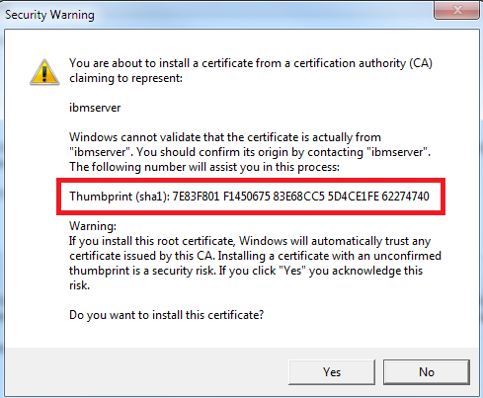

After accept this certification of this web site on your local web browser, you will not be told or blocked by your browser on the web site when you use SSL protocol to connect to this web site.

Resource Manager Administration console

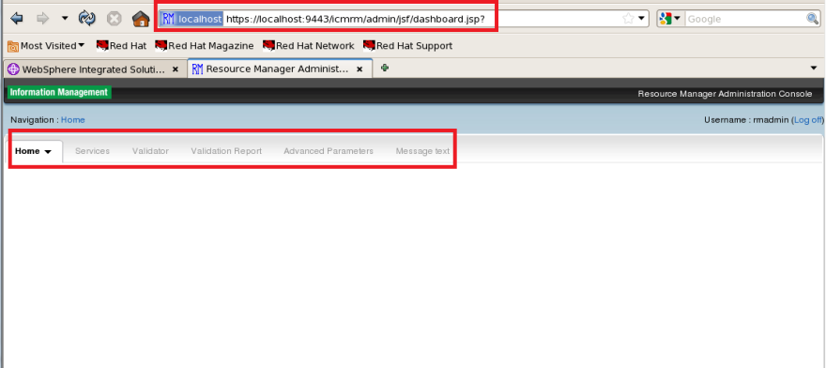

**eClient Application Installation**

In this example, we just deploy eClient java application ( eclient.ear). Before we deploy this java enterprise bean, we need to define WebSphere variables and Share libraries in WebShpere Environment.

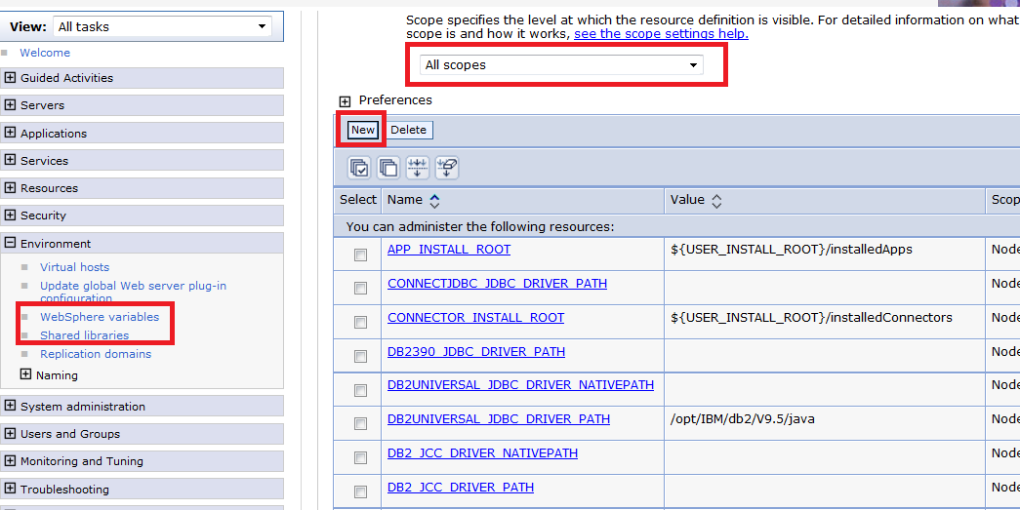

Add two webSphere Variables on node scope:

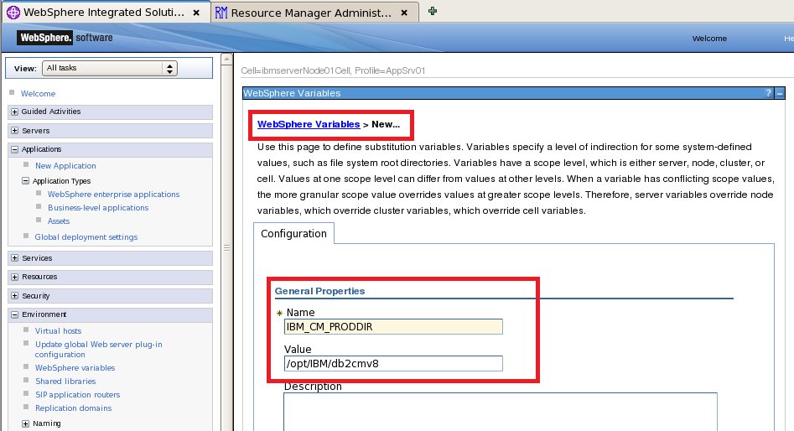

IBM_CM_PRODDIR=/opt/IBM/db2cmv8

IBM_CM_WORKDIR=/home/ibmcmadm

Add shared library on node scope:

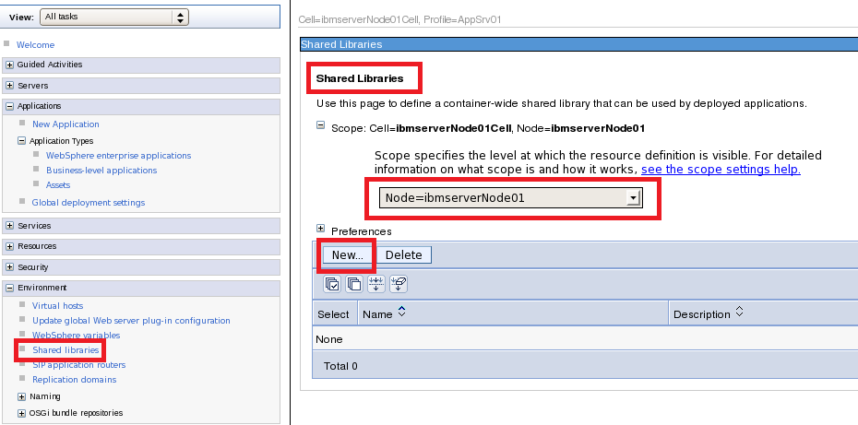

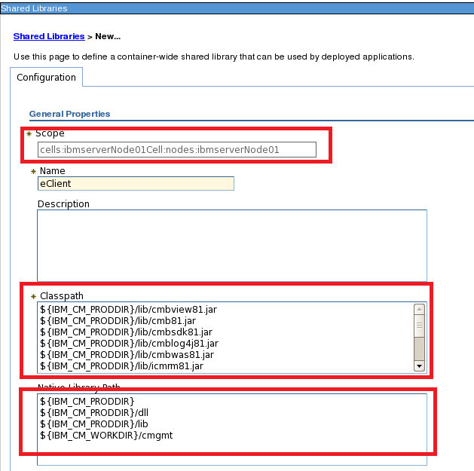

Name: eClient

Classpath:

${IBM_CM_PRODDIR}/lib/cmbview81.jar

${IBM_CM_PRODDIR}/lib/cmb81.jar

${IBM_CM_PRODDIR}/lib/cmbsdk81.jar

${IBM_CM_PRODDIR}/lib/cmblog4j81.jar

${IBM_CM_PRODDIR}/lib/cmbwas81.jar

${IBM_CM_PRODDIR}/lib/icmrm81.jar

${IBM_CM_PRODDIR}/lib/log4j-1.2.15.jar

${IBM_CM_PRODDIR}/lib/db2jcc_license_cu.jar

${IBM_CM_PRODDIR}/lib/db2jcc_license_cisuz.jar

${IBM_CM_PRODDIR}/lib/db2jcc.jar

${IBM_CM_WORKDIR}/cmgmt

${IBM_CM_PRODDIR}/cmgmt

Native Library Path

${IBM_CM_PRODDIR}

${IBM_CM_PRODDIR}/dll

${IBM_CM_PRODDIR}/lib

${IBM_CM_WORKDIR}/cmgmt

You can find that, after install Resource Manager, we install /opt/IBM/db2cmv8, but we still miss same java beans needed by eCleint, we have to copy these java bean from other eclient environment. Here I just copy two missing java beans defined in above Classpath (cmbview81.jar and cmb81.jar) from AIX server(cm07) to my Linux environment.

Run:

# scp cm07:/opt/IBM/db2cmv8/lib/cmbview81.jar ibmserver:/opt/IBM/db2cmv8/lib

# scp cm07:/opt/IBM/db2cmv8/lib/cmb81.jar ibmserver:/opt/IBM/db2cmv8/lib

**Then, we start eClient enterprise java bean installation**

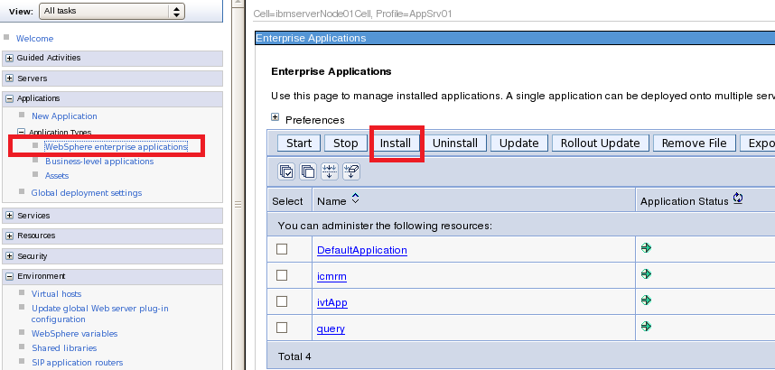

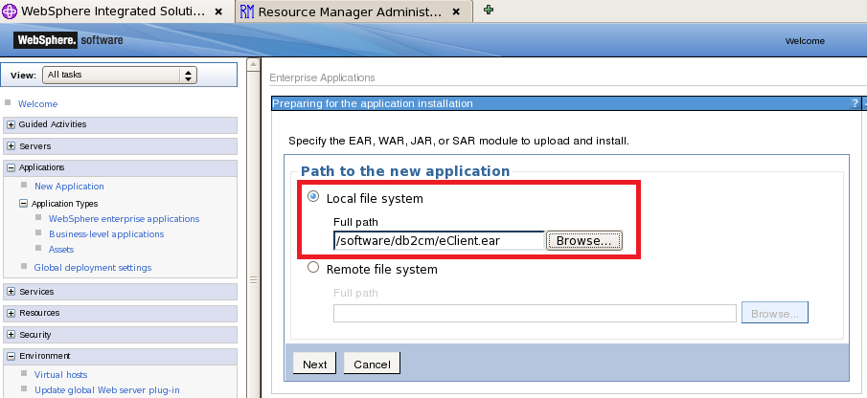

Find the eClient application, I export this eClient java application from AIX WAS Server, and copy it to my linux server.

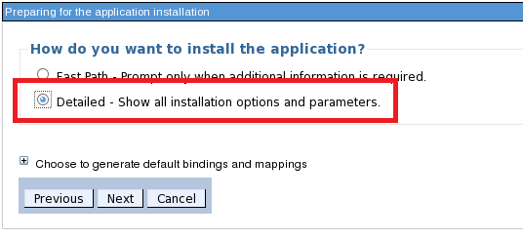

Choose Detailed installation method

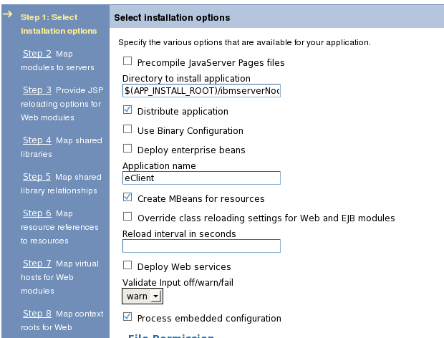

Directory to install Application: $(APP_INSTALL_ROOT)/ibmserverNode01Cell

Application name: eClient

Specify targets such as **application servers (server1)** or **clusters of application servers** where you want to install the **modules (eClient)** that are contained in your application. Modules can be installed on the same application server or dispersed among several application servers. Also, specify the Web servers as targets that serve as routers for requests to this application. The plug-in configuration file (plugin-cfg.xml) for each Web server is generated, based on the applications that are routed through.

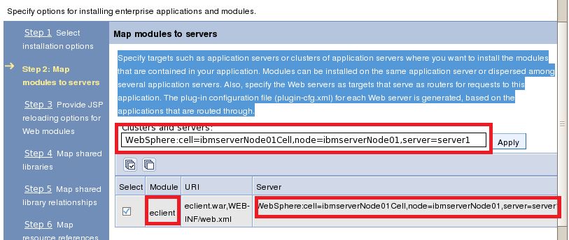

JSP reloading Options

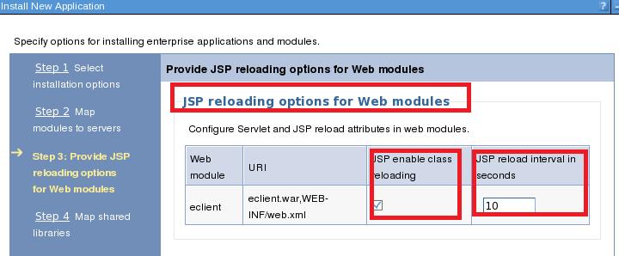

Here we map the shared library eClientLIB we defined before to eclient applation

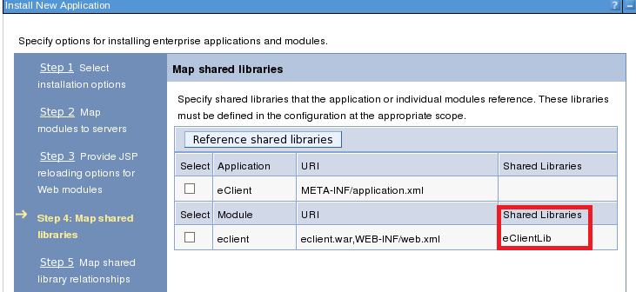

ADMA8019E: The resources that are assigned to the application are beyond the deployment target scope. Resources are within the deployment target scope if they are defined at the cell, node, server, or application level when the deployment target is a server, or at the cell, cluster, or application level when the deployment target is a cluster. Assign resources that are within the deployment target scope of the application or confirm that these resources assignments are correct as specified.

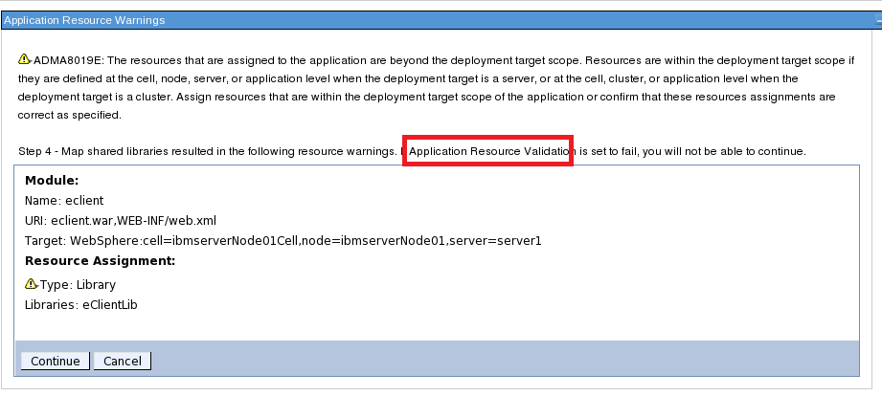

We will run validation later to verify the resource eClientLib

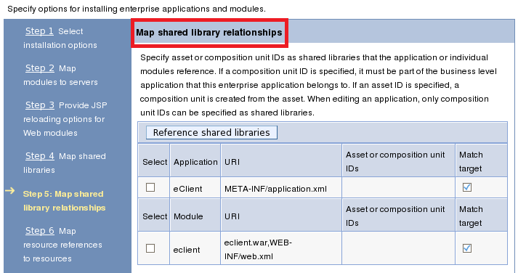

Map Resource reference to resource (JNDI name)

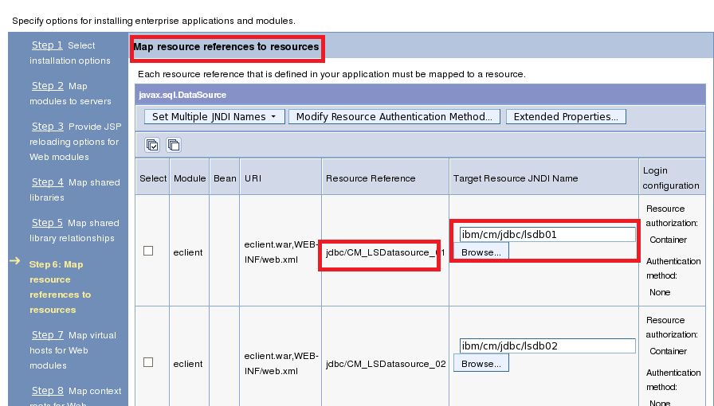

Module uses URI, Resource reference name is used to target physical Resource defined by JNDI name

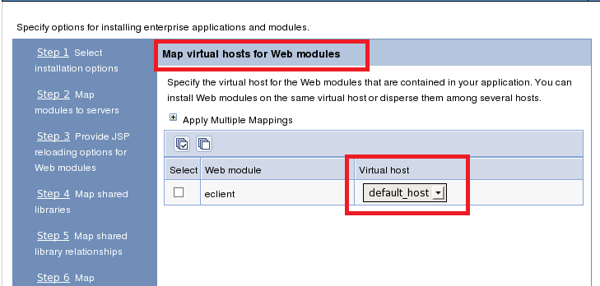

Specify the virtual host for the Web modules that are contained in your application. You can install Web modules on the same virtual host or disperse them among several hosts

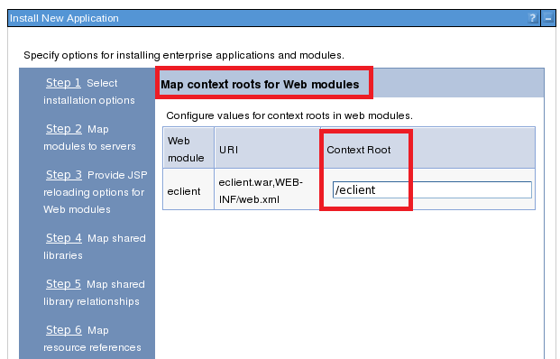

Configure values for context roots in web modules. SO, you can access this module with: <http://servername:portname/eclient>

**Installing...**

If there are enterprise beans in the application, the EJB deployment process can take several minutes. Do not save the configuration until the process completes.

Check the SystemOut.log on the deployment manager or server where the application is deployed for specific information about the EJB deployment process as it occurs.

ADMA5016I: Installation of eClient started.

ADMA0115W: Resource assignment of name jdbc/CM_LSDatasource_01 and type javax.sql.DataSource, with JNDI name ibm/cm/jdbc/lsdb01 is not found within scope of module eclient with URI eclient.war,WEB-INF/web.xml deployed to target WebSphere:cell=ibmserverNode01Cell,node=ibmserverNode01,server=server1.

ADMA0115W: Resource assignment of name jdbc/CM_LSDatasource_02 and type javax.sql.DataSource, with JNDI name ibm/cm/jdbc/lsdb02 is not found within scope of module eclient with URI eclient.war,WEB-INF/web.xml deployed to target WebSphere:cell=ibmserverNode01Cell,node=ibmserverNode01,server=server1.

ADMA0115W: Resource assignment of name jdbc/CM_LSDatasource_03 and type javax.sql.DataSource, with JNDI name ibm/cm/jdbc/lsdb03 is not found within scope of module eclient with URI eclient.war,WEB-INF/web.xml deployed to target WebSphere:cell=ibmserverNode01Cell,node=ibmserverNode01,server=server1.

ADMA0115W: Resource assignment of name jdbc/CM_LSDatasource_04 and type javax.sql.DataSource, with JNDI name ibm/cm/jdbc/lsdb04 is not found within scope of module eclient with URI eclient.war,WEB-INF/web.xml deployed to target WebSphere:cell=ibmserverNode01Cell,node=ibmserverNode01,server=server1.

ADMA0115W: Resource assignment of name jdbc/CM_LSDatasource_05 and type javax.sql.DataSource, with JNDI name ibm/cm/jdbc/lsdb05 is not found within scope of module eclient with URI eclient.war,WEB-INF/web.xml deployed to target WebSphere:cell=ibmserverNode01Cell,node=ibmserverNode01,server=server1.

ADMA0115W: Resource assignment of name jdbc/CM_LSDatasource_06 and type javax.sql.DataSource, with JNDI name ibm/cm/jdbc/lsdb06 is not found within scope of module eclient with URI eclient.war,WEB-INF/web.xml deployed to target WebSphere:cell=ibmserverNode01Cell,node=ibmserverNode01,server=server1.

ADMA0115W: Resource assignment of name jdbc/CM_LSDatasource_07 and type javax.sql.DataSource, with JNDI name ibm/cm/jdbc/lsdb07 is not found within scope of module eclient with URI eclient.war,WEB-INF/web.xml deployed to target WebSphere:cell=ibmserverNode01Cell,node=ibmserverNode01,server=server1.

ADMA0115W: Resource assignment of name jdbc/CM_LSDatasource_08 and type javax.sql.DataSource, with JNDI name ibm/cm/jdbc/lsdb08 is not found within scope of module eclient with URI eclient.war,WEB-INF/web.xml deployed to target WebSphere:cell=ibmserverNode01Cell,node=ibmserverNode01,server=server1.

ADMA0115W: Resource assignment of name jdbc/CM_LSDatasource_09 and type javax.sql.DataSource, with JNDI name ibm/cm/jdbc/lsdb09 is not found within scope of module eclient with URI eclient.war,WEB-INF/web.xml deployed to target WebSphere:cell=ibmserverNode01Cell,node=ibmserverNode01,server=server1.

ADMA0115W: Resource assignment of name jdbc/CM_LSDatasource_10 and type javax.sql.DataSource, with JNDI name ibm/cm/jdbc/lsdb10 is not found within scope of module eclient with URI eclient.war,WEB-INF/web.xml deployed to target WebSphere:cell=ibmserverNode01Cell,node=ibmserverNode01,server=server1.

ADMA0115W: Resource assignment of name jdbc/CM_LSDatasource_11 and type javax.sql.DataSource, with JNDI name ibm/cm/jdbc/lsdb11 is not found within scope of module eclient with URI eclient.war,WEB-INF/web.xml deployed to target WebSphere:cell=ibmserverNode01Cell,node=ibmserverNode01,server=server1.

ADMA0115W: Resource assignment of name jdbc/CM_LSDatasource_12 and type javax.sql.DataSource, with JNDI name ibm/cm/jdbc/lsdb12 is not found within scope of module eclient with URI eclient.war,WEB-INF/web.xml deployed to target WebSphere:cell=ibmserverNode01Cell,node=ibmserverNode01,server=server1.

ADMA0115W: Resource assignment of name jdbc/CM_LSDatasource_13 and type javax.sql.DataSource, with JNDI name ibm/cm/jdbc/lsdb13 is not found within scope of module eclient with URI eclient.war,WEB-INF/web.xml deployed to target WebSphere:cell=ibmserverNode01Cell,node=ibmserverNode01,server=server1.

ADMA0115W: Resource assignment of name jdbc/CM_LSDatasource_14 and type javax.sql.DataSource, with JNDI name ibm/cm/jdbc/lsdb14 is not found within scope of module eclient with URI eclient.war,WEB-INF/web.xml deployed to target WebSphere:cell=ibmserverNode01Cell,node=ibmserverNode01,server=server1.

ADMA0115W: Resource assignment of name jdbc/CM_LSDatasource_15 and type javax.sql.DataSource, with JNDI name ibm/cm/jdbc/lsdb15 is not found within scope of module eclient with URI eclient.war,WEB-INF/web.xml deployed to target WebSphere:cell=ibmserverNode01Cell,node=ibmserverNode01,server=server1.

ADMA0115W: Resource assignment of name jdbc/CM_LSDatasource_16 and type javax.sql.DataSource, with JNDI name ibm/cm/jdbc/lsdb16 is not found within scope of module eclient with URI eclient.war,WEB-INF/web.xml deployed to target WebSphere:cell=ibmserverNode01Cell,node=ibmserverNode01,server=server1.

ADMA0115W: Resource assignment of name jdbc/CM_LSDatasource_17 and type javax.sql.DataSource, with JNDI name ibm/cm/jdbc/lsdb17 is not found within scope of module eclient with URI eclient.war,WEB-INF/web.xml deployed to target WebSphere:cell=ibmserverNode01Cell,node=ibmserverNode01,server=server1.

ADMA0115W: Resource assignment of name jdbc/CM_LSDatasource_18 and type javax.sql.DataSource, with JNDI name ibm/cm/jdbc/lsdb18 is not found within scope of module eclient with URI eclient.war,WEB-INF/web.xml deployed to target WebSphere:cell=ibmserverNode01Cell,node=ibmserverNode01,server=server1.

ADMA0115W: Resource assignment of name jdbc/CM_LSDatasource_19 and type javax.sql.DataSource, with JNDI name ibm/cm/jdbc/lsdb19 is not found within scope of module eclient with URI eclient.war,WEB-INF/web.xml deployed to target WebSphere:cell=ibmserverNode01Cell,node=ibmserverNode01,server=server1.

ADMA0115W: Resource assignment of name jdbc/CM_LSDatasource_20 and type javax.sql.DataSource, with JNDI name ibm/cm/jdbc/lsdb20 is not found within scope of module eclient with URI eclient.war,WEB-INF/web.xml deployed to target WebSphere:cell=ibmserverNode01Cell,node=ibmserverNode01,server=server1.

ADMA0161W: The resource assignment with name eClientLib is not found within scope of module eclient with URI eclient.war,WEB-INF/web.xml that is deployed to target WebSphere:cell=ibmserverNode01Cell,node=ibmserverNode01,server=server1.

ADMA5068I: The resource validation for application eClient completed successfully, but warnings occurred during validation.

ADMA5058I: Application and module versions are validated with versions of deployment targets.

ADMA5005I: The application eClient is configured in the WebSphere Application Server repository.

ADMA5005I: The application eClient is configured in the WebSphere Application Server repository.

ADMA5081I: The bootstrap address for client module is configured in the WebSphere Application Server repository.

ADMA5053I: The library references for the installed optional package are created.

ADMA5005I: The application eClient is configured in the WebSphere Application Server repository.

ADMA5001I: The application binaries are saved in /opt/IBM/WebSphere/AppServer/profiles/AppSrv01/wstemp/0/workspace/cells/ibmserverNode01Cell/applications/eClient.ear/eClient.ear

ADMA5005I: The application eClient is configured in the WebSphere Application Server repository.

SECJ0400I: Successfully updated the application eClient with the appContextIDForSecurity information.

ADMA5005I: The application eClient is configured in the WebSphere Application Server repository.

ADMA5005I: The application eClient is configured in the WebSphere Application Server repository.

ADMA5113I: Activation plan created successfully.

ADMA5011I: The cleanup of the temp directory for application eClient is complete.

ADMA5013I: Application eClient installed successfully.

Application eClient installed successfully.

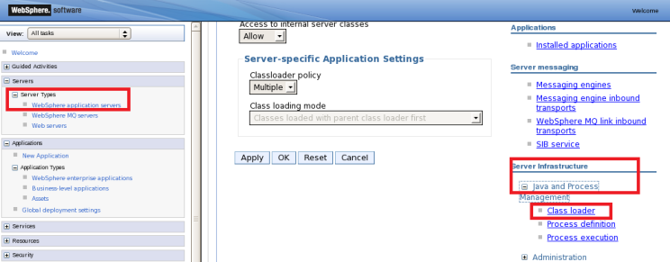

Go to the WAS Servers, define Server1 server infrastructure on java and Process Management

New Class loader

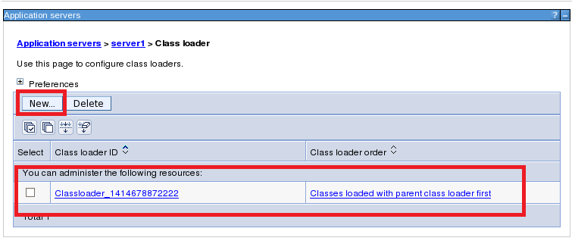

Add shared Library reference for this new created java loader

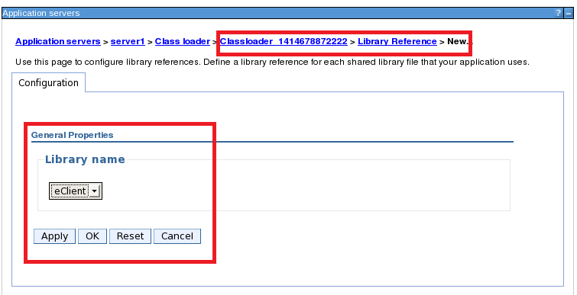

Stop/start WAS Server using First Step tool

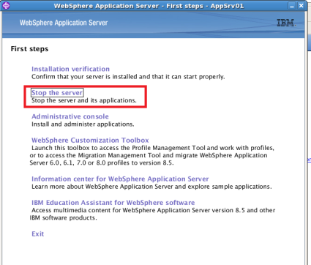

You will find the java loader eClientLib Classpath

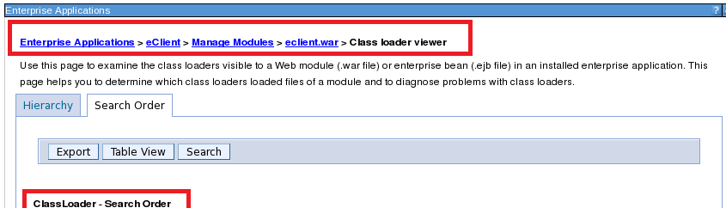

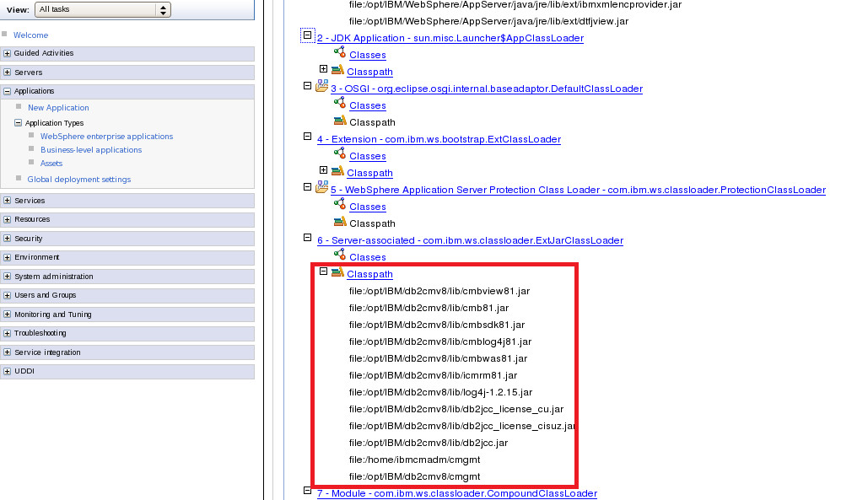

Access eClient:

<http://ibmserver:9080/eclient//IDMLogon2.jsp>

**Install IBM HTTP Server 7.0**

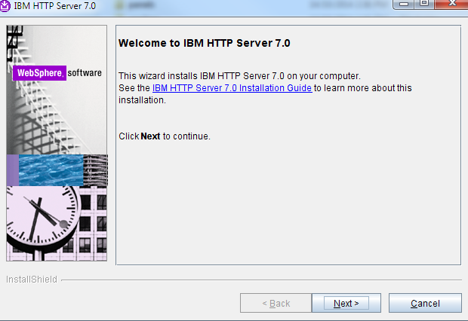

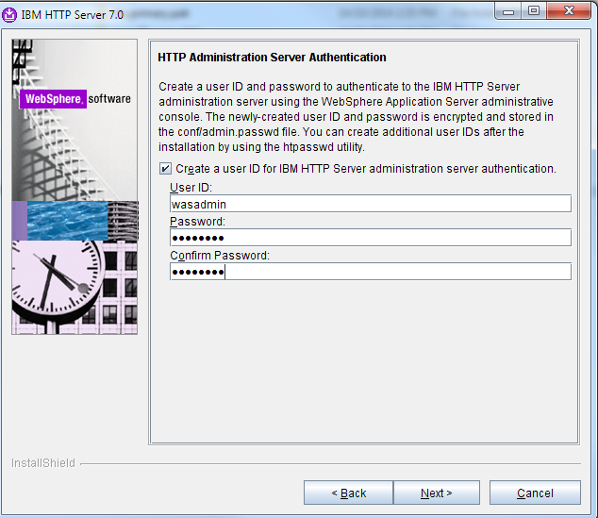

**JBDC connection authentication**

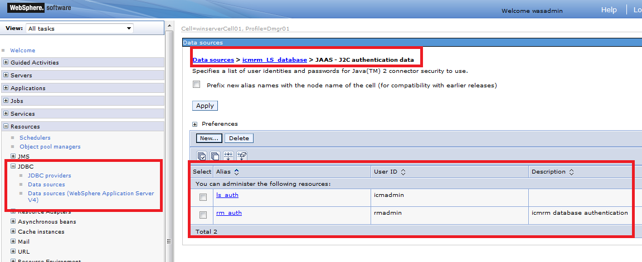

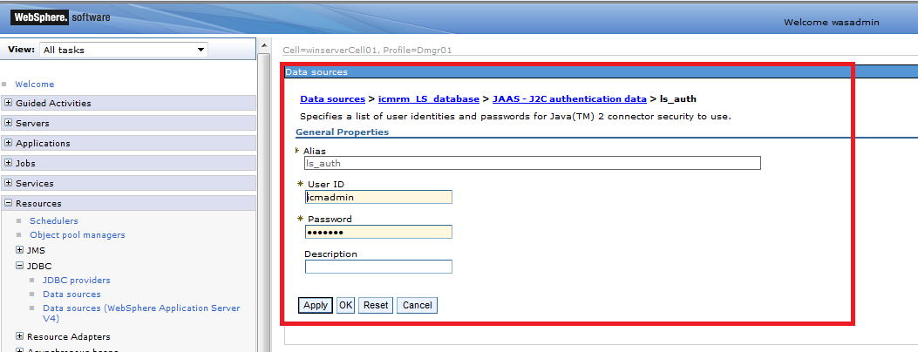

Provide DB2 database user name and password

Create new JDBC provider

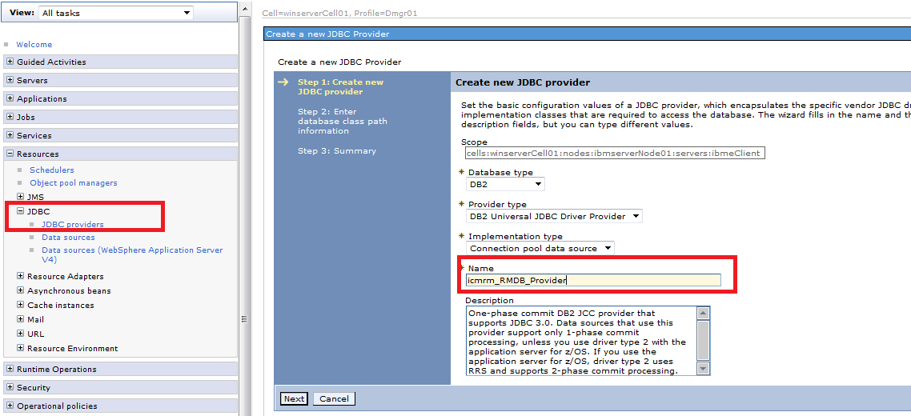

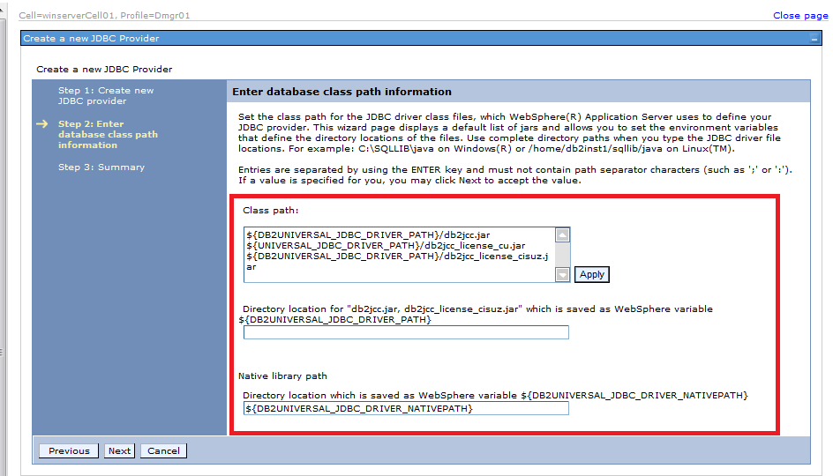

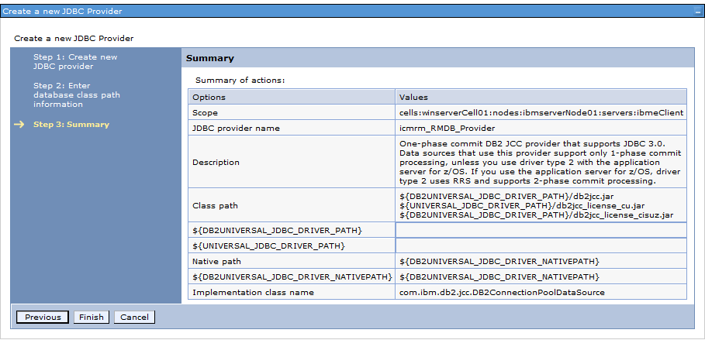

Define Data sources for JDBC providers

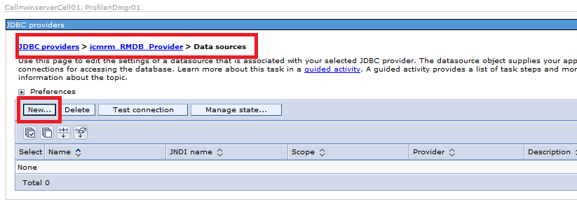

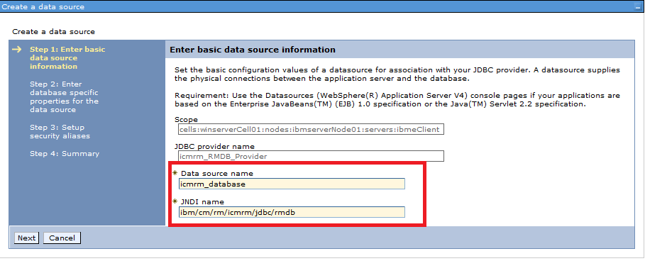

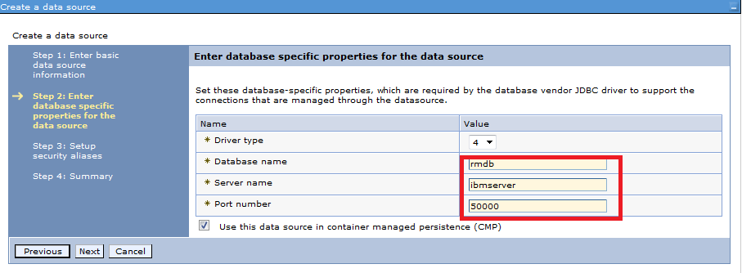

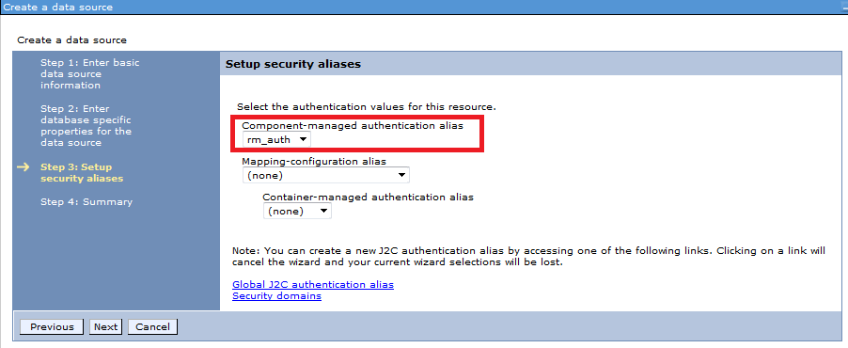

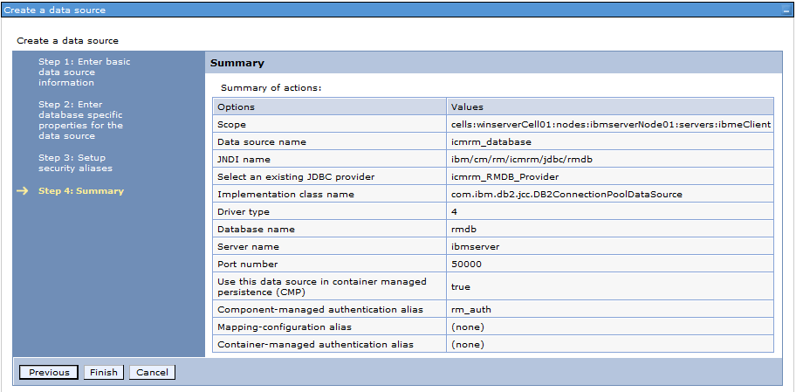

Restart Node agents after creating JDBC data sources.

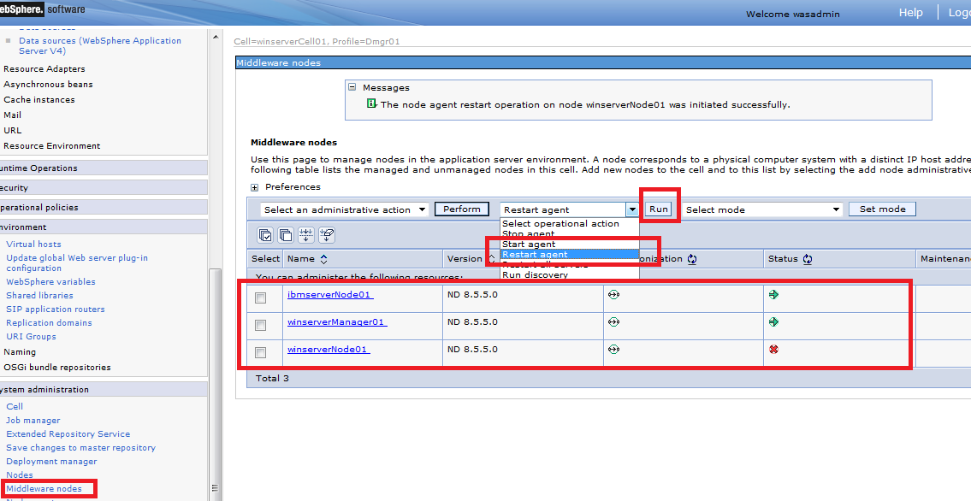

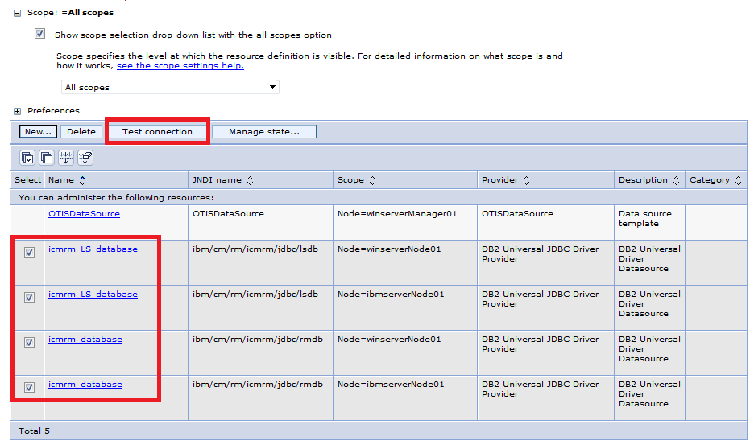

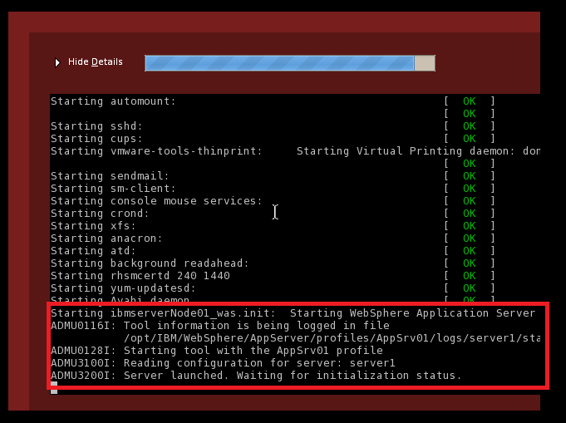

It takes extremely long time to start WAS if you change the IP and without right DNS to resolve the node/server name